Direct Access Metering
And Data Handbook

Pacific Gas and Electric Company
San Diego Gas & Electric
Southern California Edison

Last revision date: February 23, 2005

Table of Contents
About This Handbook 1
Overview 1
Disclaimer 1
Summary of Contents 1
Change Requests 2
DA Metering And Data Handbook Change Request Form 3
Communicating Direct Access Meter Characteristics Information 4
Direct Access Meter Characteristics (MC) Form 4
Instructions 5
MC Form Timeline Example 5
Sample – DA Meter Characteristics (MC) Form 6
Sample – Completed DA Meter Characteristics (MC) Form 7
DA Meter Characteristics (MC) Form Definitions 8
Customer Information Service Request (CISR) 10
Customer Information Service Request Prior to Submitting DASR 10
Sample – CISR Form (Page 1 of 2) 13
Sample – CISR Form (Page 2 of 2) 14
Metering Information Provided after DASR Approval 15
Meter Installation/Removal Scheduling Timeline Requirements 16
Scheduling Contacts/Correspondence 16
Weekly Scheduling Guidelines 16
Scheduling Timeline Example 17
Scheduling Timeline Exceptions 17
Rescheduling Timeline 17
Scheduling Notification Form 18
Scheduling Notification Form Example 19
Scheduling Notification Form Column Definitions 20
60 Days Failure to Install ESP Meter 21
Phone Lines 21
Sample PG&E Phone Service Notification Form 22
Direct Access Meter Installation/ Removal Notification (MIRN) 23
Purpose 23
Instructions 23
MIRN Timeline Example 24
Sample – Direct Access MIRN Form 25
Sample – Completed Direct Access MIRN Form 26
Direct Access MIRN Form Definitions 27
UDC Contact and Correspondence Matrix (UCCM) 30
Acceptable IDR Meter Types 32
Acceptable IDR Meter Types within SCE Service Territory 32
Acceptable IDR Meter Types within SDG&E Service Territory 34
Acceptable IDR Meter Types within PG&E Service Territory 36
California Meter and Data Exception Notice (MADEN) 37
Background 37
Purpose 37
Guidelines 38
Instructions 38
Common PG&E MADEN Data Issues – Third-Party MDMA 39
Interactive MADEN Flow 40
SCE MADEN Timeline 41
SDG&E MADEN Timeline 42
PG&E MADEN Timeline 43
Sample SCE MADEN Data 44
Sample SDG&E MADEN Data 45
Sample PG&E MADEN Data – Third-Party MDMA 46
PG&E ESP Action Report 49
PG&E Metering Issues 49
Sample ESP Action Report 52

About This Handbook

Overview
The California Utility Distribution Companies (UDCs), namely Pacific Gas & Electric (PG&E), Southern Cal Edison (SCE), and San Diego Gas & Electric (SDG&E), have compiled information in this handbook to assist customers, Meter Service Providers (MSPs), and Energy Service Providers (ESPs) in sharing Direct Access (DA) metering information and data.

Disclaimer
In the event of any conflict between the policies contained within this handbook and the DA tariffs and Energy Service Provider Service Agreement approved by the CPUC, the tariffs and Energy Service Provider Service Agreement shall control. Please note that the content of this document is subject to change as the CPUC issues further decisions relevant to DA.

Summary of Contents
This document covers the following topics:
- Communicating Direct Access Meter Characteristic Information - discusses how to use the DA Meter Characteristics (MC) Form to communicate new metering information to UDCs.
- Customer Information Service Request (CISR) – explains how to obtain customer information before a customer switches to DA and how to access meter information after a customer switches to DA.
- Meter Installation/Removal Scheduling Timeline Requirements – covers how UDCs, ESPs, and MSPs schedule metering work.
- Direct Access Meter Installation/Removal Notification (MIRN) – describes how to notify interested parties of DA meter installations and removals using the MIRN form.
- Acceptable IDR Meter Types - lists meters acceptable to each utility for DA accounts.
- California Meter and Data Exception Notice (MADEN) – describes how market participants communicate metering and data issues between themselves using a process known as MADEN.

Change Requests
Requests for changes to this handbook can be made by filling out and submitting the Direct Access Metering And Data Handbook Change Request Form. (See the following page for a copy of the form.)

DA Metering And Data Handbook Change Request Form
The following form is provided to the California Market Participants to request changes to this handbook:
Direct Access Metering and
Data Handbook Change Request Form

Name of Requester |  | Date
Company Name |  | Telephone Number
Address |  | Email Address
City, State, Zip |  | Fax Number

Type or print changes in the box below and indicate the page number(s) of the handbook where revisions are requested. Pages can also be attached if changes are extensive.
CHANGE INSTRUCTIONS
The following change is requested, subject to the terms and conditions of utility tariff schedules (including rate schedules, rules, and contracts) approved by the California Public Utilities Commission (CPUC).

CHANGE JUSTIFICATION
Include a justification for making this change to the handbook.

Email the completed form to PG&E at: DCS CRT Mitts-Meg@pge.com

For PG&E Use Only
Received By: | Date:
Work Completed By: | Date:
Notified Requester Date:
APPROVER: | ❑ Approved   Denied | Date:
(Signature) | TARIFF COMPLIANCE CONFIRMED BY:
(Print Name) | (Signature)
(Phone Number) | (Print Name)

Communicating Direct Access
Meter Characteristics Information
Direct Access Meter Characteristics (MC) Form
Energy Service Providers (ESPs) use the Direct Access Meter Characteristics (MC) form to communicate new metering type information to Utility Distribution Companies (UDCs). This form is only required the FIRST time new metering equipment is set in a UDC’s service territory. (See page 6 for a sample MC form.)
UDCs use Direct Access Meter Characteristics requests to accept and add new metering equipment information to their systems. New meters cannot be set within a UDC’s service territory until an MC has been processed and accepted for the new meter type and/or metering equipment. Therefore, UDCs must not take more than 15 calendar days to process Direct Access Meter Characteristics requests.
Note: Direct Access meters and metering equipment installed must meet minimum performance, accuracy, and safety requirements recommended by the Permanent Standards Working Group (PSWG).
- Definition of metering equipment:
- Meters
- Data Recorders (internal/external)
- Totalizers (if used for billing purposes)
- List of acceptable meter types
- Interim solution: A list of acceptable meter types for each UDC can be found in the section, “Acceptable IDR Meter Types” on pages 32–36.
- Upon acceptance of any new meter type, the UDC must update their meter type code list and provide the updated list (according to the UDC’s preferred method of communication) to the external parties (i.e., ESPs, MSPs) within 10 days of the new meter type acceptance.
Note: A Direct Access Meter Characteristics form is not required for the following devices:
- communication devices (e.g., cell phones, satellite devices, radio)
- retrofit interface devices not used for capturing billing data
Instructions
The following instructions describe how to submit metering information using the MC form:
- The ESP’s designated point of contact must submit a completed MC form to the UDC.
- Requesters must type or print in black ink to fill out the MC form. Requesters should also make a copy of the completed form for their records.
- Requesters can send completed forms by email, fax, or mail to the designated ESP metering contact as outlined in the UDC Contact and Correspondence Matrix (UCCM) on pages 30–31.
- The UDC must confirm (via email or fax) receipt of the MC form request within two (2) business days of receipt of the request.
- Within 10 calendar days of receipt of the request, the UDC must inform the ESP of the status of the request. Appropriate statuses are:
  - Accepted by UDC effective mm/dd/yy
  - Additional information required. Notification must identify specific required information.
  - Acceptance is in process. ETA of final acceptance: mm/dd/yy
- UDCs have up to 15 calendar days to process and accept MC forms.
- UDCs must communicate acceptance of the MC form to the ESPs via email or fax.
- Once the MC form request is accepted, installations are scheduled following the standard scheduling process.
- UDCs must update their meter-type code list to reflect the new meter type and provide the updated list for the external parties (i.e., ESPs, MSPs) within 10 calendar days of the new meter-type acceptance.

MC Form Timeline Example
The following is an example of a timeline to process MC forms:
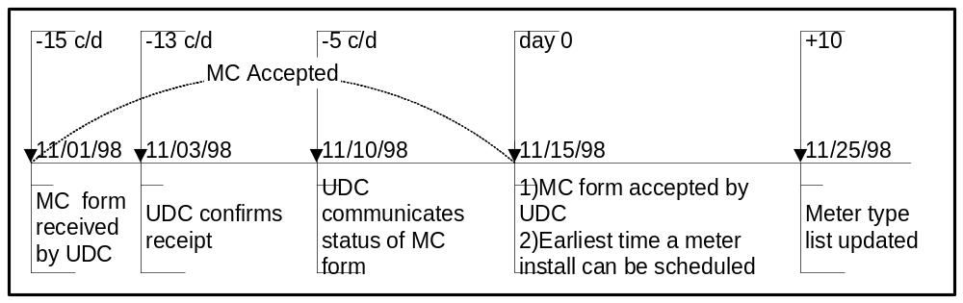

Sample – DA Meter Characteristics (MC) Form
UDC where meters will be installed | ______PG&E | _____SCE | _____SDG&E
UDC Email Address | dcsmitss-meg@pge.com | METERINS@SCE.COM | METERSVCS@Semprautilities.COM
UDC Fax Number | 415-973-2490 | 714-895-0343 | 858-547-3070 or 858-547-3030
ESP Name
ESP Contact Name
ESP Contact Phone
ESP Email Address

Meter attributes
AEP standard code Prefix
Manufacturer
Model/Mtr Type
Form
Meter Class
Meter Voltage
Test Amps
Register Type
Meter Ke
Pulse Multiplier
Meter Kh
Dial K (Rgstr Cnstnt)
Register ratio
Phase
Number of Wires

Meter Capability
 | # Dials / Display Segments | # Decimal
KWh
kW
kVARH
kVAR

TOU or IDR
TOU Capability (Y/N) |  |  |  | IDR Capability
Full Scale Max Read |  |  |  | Demand Interval Length
KWh on |  | KW on |  | # of Channels
KWh off |  | KW off |  | Interval Length
KWh Mid |  | KW Mid |  | Memory Size (K)
KWh Super off |  | KW Super off
For UDC Use Only
Accepted by @ UDC |  | Date
Note: See the following page for a sample of a completed Direct Access Meter Characteristics Form and pages 8–9 for Direct Access Meter Characteristics Form Definitions.

Sample – Completed DA Meter Characteristics (MC) Form
UDC where meters will be installed | ______PG&E | __X__SCE | _____SDG&E | _____SP
UDC Email Address | AEG3@PGE.COM | METERINS@SCE.COM | METERSVCS@Semprautilities.COM
UDC Fax Number | 415-973-2490 | 714-895-0343 | 858-574-3070
ESP Name | ABC ESP
ESP Contact Name | John Smith
ESP Contact Phone | 713-853-0333
ESP Email Address | ABCESP@XYZ.COM

Meter attributes
AEP standard code Prefix | KZG002
Manufacturer | ABB
Model/Mtr Type | A1RLQ+
Form | 9S
Meter Class | 20
Meter Voltage | 120V
Test Amps | 2.5
Register Type | -
Meter Ke | -
Pulse Multiplier | -
Meter Kh | 1.8
Dial K (Rgstr Cnstnt) | 1
Register ratio | -
Phase | 3
Number of Wires | 4

Meter Capability
 | # Dials / Display Segments | # Decimal
KWh | 5 | 0
kW | 3 | 2
kVARH | 5 | 0
kVAR | 3 | 2

TOU or IDR
TOU Capability (Y/N) |  |  |  | IDR Capability
Full Scale Max Read |  | 999.99 |  | Demand Interval Length | 15 MIN.
KWh on | Y | KW on | Y | # of Channels | 2
KWh off | Y | KW off | Y | Interval Length | 15 MIN.
KWh Mid | Y | KW Mid | Y | Memory Size (K) | 32K
KWh Super off | Y | KW Super off | Y

For UDC Use Only
Accepted by @ UDC |  | Date
- Meter type for SCE service territory, ABB model A1R1Q+ form 9S, 120 volt, 2-channel TOU and IDR meter.

DA Meter Characteristics (MC) Form Definitions
Direct Access Meter Characteristics (MC) Form Definitions
Title | Description
UDC where meter will be installed | The UDC area where the meter(s) is to be installed as follows:  PG&E: Pacific Gas and Electric Company  SCE: Southern California Edison  SDG&E: San Diego Gas and Electric
UDC Email Address | UDC’s email address for returning a completed MC form.
UDC Fax Number | UDC’s fax number for returning a completed MC form.
ESP Name | Name of the Energy Service Provider.
ESP Contact Name | Name of the Energy Service Provider’s contact person.
ESP Contact Phone | Phone number of the Energy Service Provider’s contact person.
ESP Email Address | Email address of the Energy Service Provider’s contact person.
Meter Attributes
AEP standard code Prefix | American Electric Power code identifies the service type and manufacturer (3-character code). The AEP code includes Form, Wires, Phase, Volts, Test Amps, and Kh.
Manufacturer | Manufacturer of the meter.
Model/Mtr Type | Meter or recorder type listed on the plate.
Form | Meter Form that contains condensed meter characteristics for the meter.
Meter Class | The maximum of the watthour meter load range in amperes.
Meter Voltage | Voltage of the meter. Note if auto ranging.
Test Amps | Amps at which the meter is calibrated.
Register Type | The type of register designated by the manufacturer that the meter uses to record and store energy usage.
Meter Ke | The watthour per pulse value programmed into a solid state meter/recorder.  Ke Value Formula:  Pulse Constant / Billing Constant x 1000 = Ke
Pulse Multiplier | The factor used on solid state meters to convert pulses of energy to kilowatt usage per hour (also known as the pulse constant).  Formula (for meters with Ke values):  Billing Constant x Ke / 1000 = Pulse Multiplier
Meter Kh | The number of watthours represented by one revolution of the disk. Also called disk constant.
Dial K (Rgstr Cnstnt) | The multiplier applied to the register reading to obtain kilowatthours (does not include CT/PT ratios).
Register ratio | The number of revolution of the gear meshing with the worm or pinion on the rotating element for one revolution of the first dial pointer.
Phase | Number of phases of the service and/or meter.
Number of Wires | Number of wires of the service and/or meter.
Meter Capability
Show the number of dials (on mechanical meter)/display segments (on solid state meter) and decimal for the following units of measure.
kWh | Unit of measure in kilowatthours (1000 watthours).
kW | Unit of measure in kilowatts (1000 watts) (Demand).
kVARH | Unit of measure in kilo volt ampere reactive hours.
kVAR | Unit of measure in kilo volt ampere reactive (Reactive Demand).
TOU (Time of Use) Capability
- Demand is the measured energy usage over a specified interval of time divided by that interval of time.
Full Scale Maximum Read | The highest capacity of the meter to measure demand. Show the decimal.
Enter Yes (Y) or No (N) to indicate whether or not there is TOU display capability for the following time periods.
On | On peak time period.
Off | Off peak time period.
Mid | Mid peak time period.
Super Off | Super Off peak time period
IDR (Interval Data Recorder) Capability
If IDR capable, enter applicable data.
Demand Interval length | The time increment, in minutes, used to record demand data; for example, energy usage may be recorded every 5, 15, or 30 minutes.
# of Channels | The maximum number of channels on the meter/recorder.
Interval Length | The time increment, in minutes, used to record interval data; for example, energy usage may be recorded every 5, 15, or 30 minutes.
Memory Size (K) | The memory size of the meter/recorder in kilobytes (thousands).

Customer Information Service Request (CISR)

Customer Information Service Request Prior to Submitting DASR
The following sections describe how ESPs obtain customer information before submitting a Direct Access Service Request (DASR).
Southern California Edison (SCE), Pacific Gas and Electric (PG&E), and San Diego Gas and Electric (SDG&E) have implemented a consolidated Customer Information Service Request (CISR) form which customers use to grant authorization to a designed Agent and Consultant (Agent) to receive service account information or act on their behalf. (See pages 13–14 for a sample CISR.) The CISR was designed to simplify the authorization process as well as to protect the privacy rights of customers. Therefore, any alterations to the CISR after it has been executed by a customer will render the CISR null and void. (Note: SCE and SDG&E customers may also submit a letter granting authorization to an Agent in lieu of using the CISR form. The letter must be written on the customer’s own letterhead and indicate the specific service account(s) and the information they are requesting be provided to their Agent.)
In addition to the CISR, each utility provides information on metering relationships and the current meter serial read date.
For further information on obtaining metering information, see the PG&E ESP Handbook, Chapter 8, or each utility’s website at:
SDG&E: http://www.sdge.com/business/esp/electric/
SCE: http://www.sce.com/sc3/008_sales/008e_esp/008e1_get_started/008e1a_reg_kit.htm
PG&E: http://www.pge.com/docs/pdfs/customer_service/english_brochures/customer_behalf_app.pdf or,
http://www.pge.com/suppliers_purchasing/customer_choice/esp_resource_center/esp_handbook/index.html

How SCE Provides Customer Information
SCE receives and processes requests for customer information as follows:
Submitting the Authorization
- All completed and fully executed authorization requests should be mailed to: Southern California Edison, Customer Billing Center, Third Party Authorization, P.O. Box 6400, Rancho Cucamonga, CA 91729, faxed to: (909) 942-8144, or emailed to: 3rdparty@sce.com. The requester keeps a copy of the completed CISR form for their records.
- Submission of this form only provides the agent with authorization by an SCE customer to request and receive data and/or perform certain functions on their behalf. Once a copy of this fully executed form is on file with SCE, the Agent must provide SCE with a written request (email is acceptable) for information or action to be taken before any information is released or action is taken by SCE. The Agent’s written request must identify specific service account(s) and detail the specific information that the requester wishes SCE release and/or the specific functions requested that SCE perform.
Release of Account Information
- Customers must indicate how SCE should provide the information requested to their Agent. Most information is available either by:
- Hard copy via US Mail,
- Fax (909) 942-8144, or
- Electronic format via electronic mail. Note: SCE cannot guarantee the confidentiality of customer information delivered via electronic mail.
- Customer must complete and sign the CISR form or their letter of authorization drafted on the customer’s own letterhead. Note: The CISR form or letter of authorization must be signed by someone in the customer’s organization who has the authority to financially bind the customer (e.g., the CFO of a company or City Manager of a municipality).
- The Agent must also read and sign the CISR form.
- SCE does not guarantee the accuracy of rate analysis when the customer or agent provides usage information.

How SDG&E Provides Customer Information
San Diego Gas & Electric provides down loadable forms and instructions for obtaining customer information at their web site: http://www.sdge.com/business/esp/electric/forms/
SDG&E verifies that the form is completed and signed by the customer and emails the requested information within 10 days.

How PG&E Provides Customer Information
To request information for a customer, the ESP must obtain and provide a signed CISR form and indicate the specific customer account numbers for the requested information. All completed forms can be faxed or emailed to:
Robert Reeder
RWR6@PGE.COM
Fax (415) 973-2377
Phone (415) 973-5480
After verifying both pages of the CISR are completed and signed by the customer and ESP, PG&E forwards the information by email within five (5) working days of its receipt. PG&E provides DA customer data free of charge for up to two times a year. However, a $40.00 charge per data set will apply to subsequent requests.
ESPs with questions regarding a request status should contact Robert Reeder directly or the ESP Services hotline at (415) 973-1666.

Sample – CISR Form (Page 1 of 2)
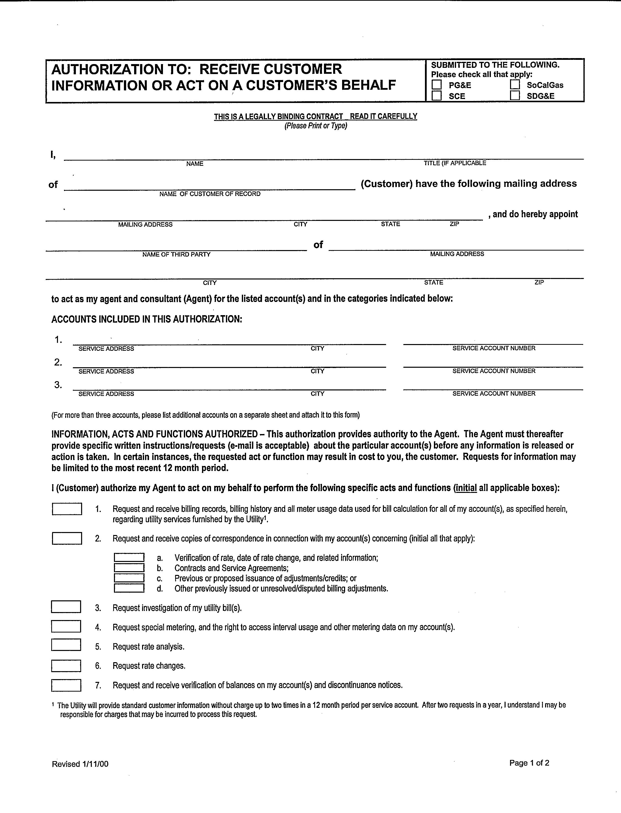

Sample – CISR Form (Page 2 of 2)
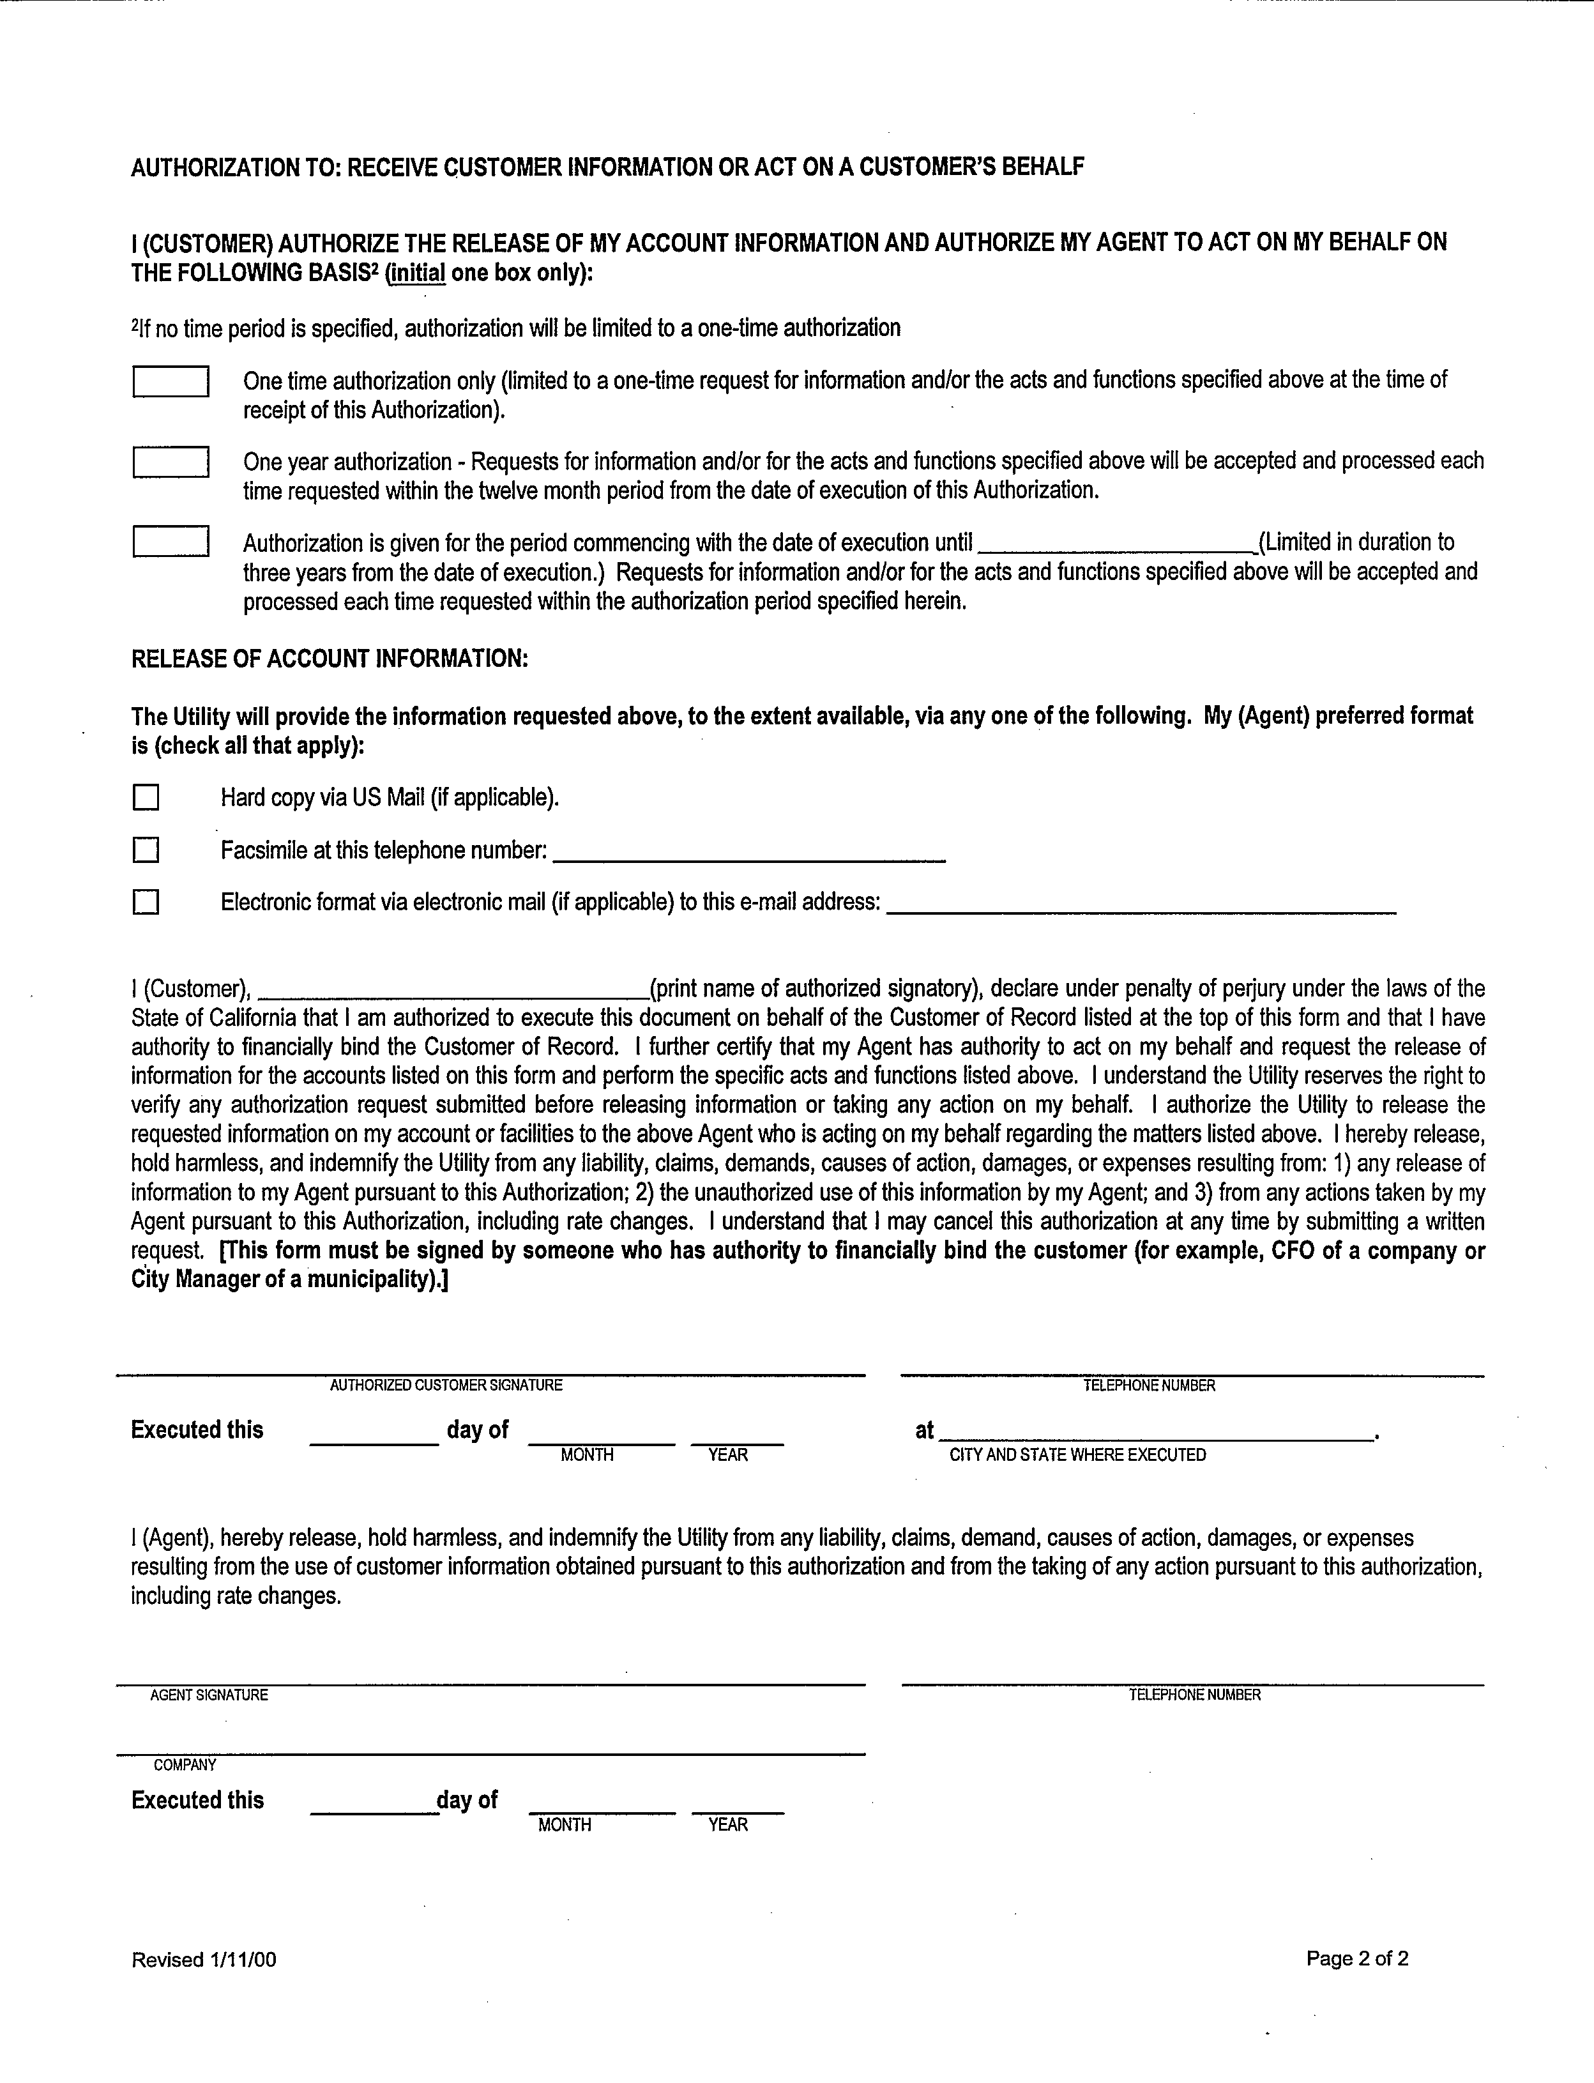

Metering Information Provided after DASR Approval
Once a DASR has been accepted and approved, the UDCs provide meter configuration data (including the meter number, meter type, and service voltage) and Telecom information (including the Baud Rate, Ke, phone number, and remarks from the field) as follows:

How SCE Provides Meter Information
SCE posts meter information to their website at:
http://www.sce.com/DoingBusiness/ESP/GettingStarted/GuidesandTools/Default.htm

How SDG&E Provides Meter Information
SDG&E sends meter information as an email attachment.

How PG&E Provides Meter Information
PG&E posts meter information to the PG&E 3rd Party website at: http://meterinfo/3rdparty/login.asp

Meter Installation/Removal Scheduling Timeline Requirements

Scheduling Contacts/Correspondence
When an ESP subcontracts metering services to a Meter Service Provider (MSP), UDCs communicate directly with the ESP’s designated point of contact (i.e., the MSP) for scheduling and managing meter installations and removals. Communications between ESPs and MSPs regarding installations remain the responsibility of the ESPs and MSPs.
All meter installation/removal scheduling must be coordinated through:
- PG&E: Meter Event Group
- SCE: Metering Scheduling Coordinators
- SDG&E: Electric Metering Operations
Phone, fax, email, and mail address information is listed on the UDC Contact and Correspondence Matrix (UCCM) on pages 30–31.
If a UDC receives scheduling notifications (i.e., the Scheduling Notification form) for the same customer account from multiple MSPs, the UDC contacts the ESP to resolve the conflict.

Weekly Scheduling Guidelines
The following are guidelines to follow when scheduling metering work:
- UDCs require the installation schedule spreadsheet (i.e., the Scheduling Notification form) by Thursday AM for the following week. Note: The Scheduling Notification form may be emailed to the appropriate UDC representative.
- Additions and modifications to the weekly schedule require one (1) business day advance notification.
- Meter Information (MI) responses can be submitted on a daily basis.
- UDCs communicate any exceptions to the MSPs within one (1) business day of receipt.

Scheduling Timeline Example
The following is an example of a timeline to schedule metering work:
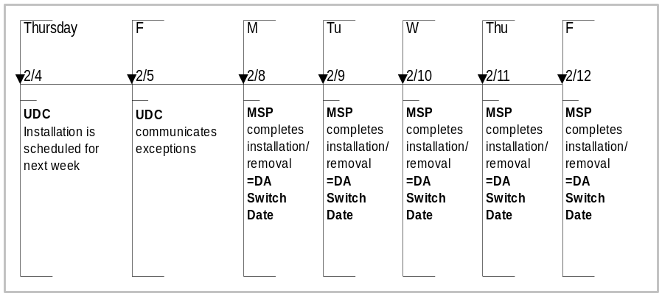

Scheduling Timeline Exceptions
A minimum of three (3) days advanced scheduling notification is required for the following installation types/exceptions:
- DASR exceptions
- Joint meets
- Credit security (Note: UDCs work with ESPs to ensure credit security exceptions/issues are properly handled and communicated.)
- Major load (e.g., greater than 500kW)

Rescheduling Timeline
Rescheduling or un-scheduling during the week can be accomplished by contacting the appropriate UDC contact by phone or email.
If a scheduled meter installation cannot be performed by the MSP on the currently scheduled date, the UDC’s metering scheduling coordinator must be notified within one (1) business day of the missed installation and the meter installation must be rescheduled or un-scheduled.
The installation can be rescheduled to any one (1) business day following the missed scheduled date. Notifications must be received by 3:00 p.m. for the next business day to reschedule or un-schedule an installation.
It is the responsibility of the MSP to notify the ESP of any missed installations or rescheduled installation dates according to timeline requirements defined within their service agreement/business contract.
Scheduling Notification Form
MSPs, ESPs, and UDCs use the Scheduling Notification form to communicate the following transactions for meter work:
- Scheduling
- Rescheduling
- Un-scheduling
- MI Response
- Exceptions (UDCs notifying MSPs/ESPs of exceptions)
A single Scheduling Notification form must only contain new or revised transactions. Unchanged previously sent transactions must be excluded.

Scheduling Notification Form Example
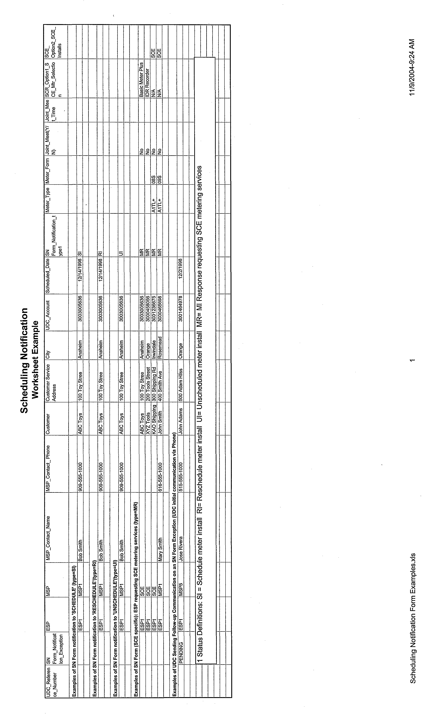

Scheduling Notification Form Column Definitions
 | Columns | Required (R) / Notes
 | UDC reference number | Optional for SCE; R for others
 | Scheduling Notification form exceptions. UDC will indicate “PENDING” in this column if the requested schedule date cannot be met. | To be filled out by UDCs
 | ESP ticker ID | R
 | MSP ticker ID | R
 | MSP contact name | R
 | MSP contact phone | R
 | Customer name | R
 | Address | R
 | City | R
 | UDC service account number (of the customer) | R
 | Scheduled date | As appropriate
 | Scheduling Notification form notification types:  - SI = Schedule meter install  - RI = Reschedule meter install  - UI = Un-schedule meter install  - MR= MI Response from ESP requesting SCE metering selections  - RP = Reprogramming | R
 | Joint Meet (Y/N)  Note: If joint meet, phone number or pager of MSP contact must be provided. | Only if “Y”
 | Joint meet time | As appropriate
 | Meter type | R for SDG&E  For SCE, R if MI response
 | Meter form | R for SDG&E  For SCE, R if MI response
 | Following applies to SCE MI Response only:
 | SCE Option 1 - SCE Meter Selection | As appropriate
 | SCE Option 2 - SCE Installs Meter Provided by ESP | As appropriate (i.e., if worksheet is coming from MSP, then this is not needed). Entering “SCE” within this column indicates ESP wishes to have SCE perform the installation.

60 Days Failure to Install ESP Meter
As defined by the switching exemption rules implemented February 2004, pending DASRs that are awaiting DA meter installation for more than 60 calendar days will be suspended by the UDCs. The ESP will be notified that the account has been switched to DA with meter and MDMA services provided by the UDC. The ESP has the option of installing the ESP meter at a later date.
For details on DA switching rules in the PG&E service territory, see the PG&E ESP Handbook, Chapter 5, or the PG&E website at: http://www.pge.com/suppliers_purchasing/customer_choice/esp_resource_center/esp_handbook/
index.html
For details on DA switching rules in the SCE service territory, see the SCE ESP Handbook, Chapter 18, or the SCE website at: http://www.sce.com/sc3/008_sales/008e_esp/008e1_get_started/008e1a_reg_kit.htm
For details on DA Switching Rules in the SDG&E service territory, see the SDG&E web site at: http://www.sdge.com/business/esp/electric/startup/

Phone Lines
The coordination of a phone line with the meter installation is crucial. The ESP is responsible for the phone line installation and ongoing maintenance. Once a phone line is installed, the ESP notifies PG&E by faxing a “Phone Service Notification” form to DCS CRT Mitts-Meg. (See the following page for a sample Phone Service Notification form.)
For additional details on phone line requirements, see the PG&E ESP Handbook, Chapter 5, or PG&E’s website at: http://www.pge.com/suppliers_purchasing/customer_choice/esp_resource_center/esp_handbook/
index.html
For detailed information on phone line connectivity issues and timeframes to resolve these issues, see page 50.

Sample PG&E Phone Service Notification Form
 Phone Service Notification

Customer Information
Customer Name |  | Contact Number
Service Account Number |  | Service Address |  | Service City
Energy Service Provider Information
Name |  | Date
Address
City |  | State |  | ZIP
Contact Name |  | Contact Title
Contact Phone Number |  | Fax Number |  | Email address
Meter Phone Service Information
 |  |  |  |  | Hardwire |  |  | Cellular
Meter phone service provider
Meter phone number |  | Date phone service was activated |  | Meter number
Send this form to PG&E:
Mail to: PG&E Meter Event Group c/o Shirley Fernan
PO Box 770000, Mail Code B14F, San Francisco, CA 94177
Delivery: 77 Beale Street, 14th Floor, San Francisco, CA
Email DCS CRT Mitts-Meg@pge.com
Fax: (415) 973-2490
For Office Use Only
 | Received Date |  | Received by |  |  |  |  |  |  | Phone Service Line Confirmed by
 | Contact to Resolve Problem |  | RAS |  |  |  |  | ESP |  | Date
 | Description of Problem:
 | Problem Corrected Date

Direct Access Meter Installation/ Removal Notification (MIRN)

Purpose
MSPs use Direct Access Meter Installation/Removal Notifications (MIRNs) to communicate specific meter installation/removal information to the appropriate UDC and ESP. This form is required for meter changes, meter removals, and meter sets.
The UDC and ESP must receive a completed MIRN within three (3) business days of a meter installation/removal.
Note: PGE notifies third parties of meter installation/removal activities through their 3rd Party website at: http://meterinfo/3rdparty/login.asp

Instructions
The following instructions describe how to use a MIRN to notify UDCs and ESPs of metering work:
- MSPs complete the MIRN form with the information collected at meter installation/removal time.
- MSPs make a copy of the completed MIRN form for their records.
- MSPs send completed MIRN forms to the designated UDC metering contact as outlined in the UDC Contact and Correspondence Matrix (UCCM) on pages 30–31.
- If the MIRNs are sent via fax, MSPs send an email to the UDC identifying the total number of MIRNs to expect via fax. Note: The UDCs use this total count to determine if any faxed MIRNs are missing.
- UDCs contact the MSPs immediately (i.e., the same or next business day) for missing, incomplete, or illegible faxed sheets.
- MSPs must respond to any discrepancies within 24 hours of notification.
- MSPs send completed MIRN forms to the designated ESP metering contact, where applicable.
Note: The UDC and, where applicable, the ESP must receive a completed MIRN within three (3) business days of the meter installation/removal.
- On the scheduled meter installation/removal date plus three (3) business days, the UDC notifies the ESP of any MIRNs not received.
- The ESP must arrange to have the MSP return the completed MIRN form to the UDC or provide a reschedule date within 24 hours of the notification.
- MSPs must return removed UDC meters to the UDCs within 30 business days of removal.
- UDCs return removed customer meters to the ESP/MSP within 30 business days of removal.

MIRN Timeline Example
The following is an example of a timeline used to monitor MIRNs:
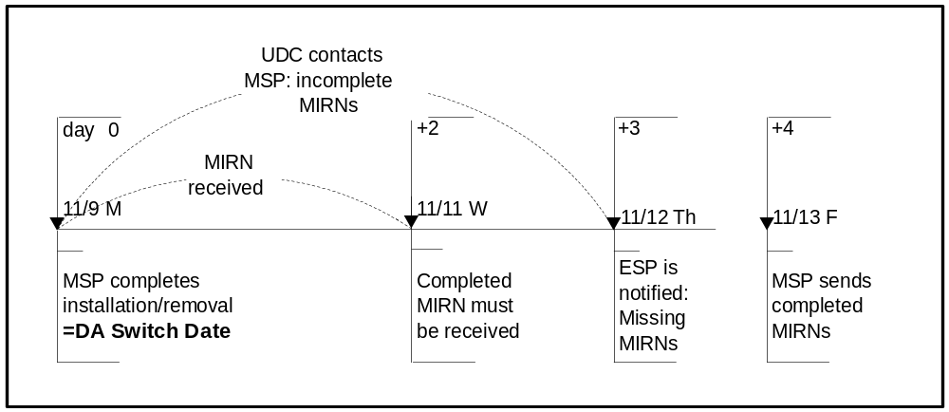

Sample – Direct Access MIRN Form
¹UDC and reference number | ^{1A} ESP | ³Mtr Activity |  | ⁴Event Date:
____PG&E - Order # ________________ | Work | __ Change |  | ⁵Event Time:
____SCE | Order | __ Set |  | ^{6a}ESP:
____SDG&E - DASR # ______________ | Number | __ Remove |  | ^{6b}ESP Account Number:
 |  | __ Reprogram |  | ⁷MSP:
 |  | __Config.Chg
²SDPI |  |  | ⁸UDC Account No: |  |  | ⁹Read Cycle:
^{10a}Service Address: |  |  |  |  | ^{10b}City
¹¹Customer Name: |  |  | ¹²Business name:

²⁰Meter Information | ^{20A}As Found Meter (Old) | ^{2OB}As Left Meter (New)
^{21A,B}Meter Number
^{22A,B}RKVA Meter Number
^{23A,B}External Recorder Number
^{24A,B}ESP Meter Number

 | ^{30A} As Found (Old) |  | ^{30B} As Left (New) |  | ⁶⁰ New or Change Meter & Site Configuration
 | ^{31A}Display # | ^{31B}Read | ^{31C}Display # | ^{31D}Read | Meter Config
³²Meter Date |  |  |  |  | ⁶¹ Manufacturer
³³Meter Time |  |  |  |  | ⁶² Model/Mtr Type
³⁴Mechanical Read |  |  |  |  | ⁶³ Model/Recorder Type
³⁵Total Kwh Read |  |  |  |  | ⁶⁴ Form
³⁶Total Kw Read |  |  |  |  | ⁶⁵ Meter Class
³⁷Tot. RKVA Reads |  |  |  |  | ⁶⁶ Meter Voltage
³⁸TOU Read |  |  |  |  | ⁶⁷ Test Amps
³⁹TOU Read |  |  |  |  | Solid State
⁴⁰TOU Read |  |  |  |  | ⁷⁰ Register Type
⁴¹TOU Read |  |  |  |  | ⁷¹ Optical port
⁴²TOU Read |  |  |  |  | ⁷² Radio communicate
⁴³TOU Read |  |  |  |  | ⁷³ # of Display Segments
⁴⁴TOU Read |  |  |  |  | ⁷⁴ Pgm ID Name
⁴⁵TOU Read |  |  |  |  | ⁷⁵ Meter Ke
⁴⁶TOU Read |  |  |  |  | ⁷⁶ Pulse Multiplier
⁴⁷TOU Read |  |  |  |  | ⁷⁷# of IDR Channels
⁴⁸TOU Read |  |  |  |  | Mechanical
⁴⁹TOU Read |  |  |  |  | ⁸⁰ Number of Dials
⁵⁰TOU Read |  |  |  |  | ⁸¹ Meter Kh
⁵¹TOU Read |  |  |  |  | ⁸² Dial K (Rgstr Cnstnt)
⁵²TOU Read |  |  |  |  | ⁸³ Register Ratio
⁵³TOU Read |  |  |  |  | ⁸⁴ Billing Constant
⁵⁴TOU Read |  |  |  |  | ⁸⁵ KYZ Output (External)
⁵⁵TOU Read |  |  |  |  | Site Info
⁵⁶TOU Read |  |  |  |  | ⁹⁰ Phase |  | 1____3____ Net____
⁵⁷TOU Read |  |  |  |  | ⁹¹ Number of Wires |  | 1____3____4_____
¹⁰² Customer de-energized (Y/N): |  |  |  |  |  | ⁹² Delta/Wye | Delta ___ Wye ___
¹⁰³ Remarks |  |  |  |  |  | ⁹³ Service Voltage
 |  |  |  |  |  | ⁹⁴ CT Quantity
 |  |  |  |  |  | ⁹⁵ CT Ratio
 |  |  |  |  |  | ⁹⁶ PT Quantity
 |  |  |  |  |  | ⁹⁷ PT Ratio
24-Hour Emergency Contacts |  |  |  |  |  | ¹⁰⁰ Meter Com. Tele #
PG&E: 800-743-5000 **SCE: 800-611-1911 ** SDG&E: 800-611-7343 ** SP: - - |  |  |  |  |  | ¹⁰¹ Internal Meter ID

Note: See the following page for a sample of a completed Direct Access MIRN Form and pages 27–29 for Direct Access MIRN Form Definitions.

Sample – Completed Direct Access MIRN Form
¹UDC and reference number | ^{1A} ESP | ³Mtr Activity |  | ⁴Event Date: 8/7/98
____PG&E - Order # ________________ | Work Order | __ Change |  | ⁵Event Time: 12:16
__X_SCE | Number | __ Set |  | ^{6a}ESP: ABC ESP
____SDG&E - DASR # _______________ | 12345678901 | __ Remove |  | ^{6b}ESP Account Number: 123456789
____SP – DASR # __________________ | 234 | __ Reprogram |  | ⁷MSP: ABC MSP
 |  | __Config.Chg
²SDPI |  |  | ⁸UDC Account Number 3000438899 |  |  | ⁹Read Cycle: 54
^{10a}Service Address: 35550 AVENIDA LA CRESTA |  |  |  |  | ^{10b} CITY MURRIETA
¹¹Customer Name: ABC TOOLS |  |  | ¹²Business name: ABC Tools

²⁰Meter Information | ^{20A}As Found Meter (Old) | ^{2OB}As Left Meter (New)
^{21A,B}Meter Number | PO726K-2375 | KZFAAA-001455
^{22A,B}RKVA Meter Number | RP0126-1449 | REMOVED
^{23A,B}External Recorder Number
^{24A,B}ESP Meter Number

 | ^{30A} As Found (Old) |  | ^{30B} As Left (New) |  | ⁶⁰ New or Change Meter & Site Configuration
 | ^{31A}Display # | ^{31B}Read | ^{31C}Display # | ^{31D}Read | Meter Config
³²Meter Date | 01 | 080798 |  |  | ⁶¹ Manufacturer | SCHLUMBERGER
³³Meter Time | 02 | 1216 |  |  | ⁶² Model/Mtr Type | SV3SR
³⁴Mechanical Read |  | 2587 |  |  | ⁶³ Model/Recorder Type | -
³⁵Total Kwh Read |  | 12597 |  | 00000 | ⁶⁴ Form | 9S
³⁶Total Kw Read |  | 1.95 |  | 0.00 | ⁶⁵ Meter Class | 20
³⁷Tot. RKVA Reads |  | 7480 |  | REMOVED | ⁶⁶ Meter Voltage | 277
³⁸TOU Read | 008 | 002375 |  |  | ⁶⁷ Test Amps | 2.5
³⁹TOU Read | 03 | 5 |  |  | Solid State
⁴⁰TOU Read | 04 | 12597 |  |  | ⁷⁰ Register Type | SV3SR
⁴¹TOU Read | 05 | 00028 |  |  | ⁷¹ Optical port | Y
⁴²TOU Read | 06 | 0.01 |  |  | ⁷² Radio communicate
⁴³TOU Read | 09 | 07945 |  |  | ⁷³ # of Display Segments
⁴⁴TOU Read | 10 | 1.95 |  |  | ⁷⁴ Pgm ID Name
⁴⁵TOU Read | 13 | 04623 |  |  | ⁷⁵ Meter Ke | .06
⁴⁶TOU Read | 14 | 1.95 |  |  | ⁷⁶ Pulse Multiplier | .096
⁴⁷TOU Read | 18 | 00025 |  |  | ⁷⁷# of IDR Channels | 2
⁴⁸TOU Read | 19 | 0.00 |  |  | Mechanical
⁴⁹TOU Read | 22 | 07146 |  |  | ⁸⁰ Number of Dials | 5
⁵⁰TOU Read | 23 | 1.95 |  |  | ⁸¹ Meter Kh | 1.8
⁵¹TOU Read | 26 | 04123 |  |  | ⁸² Dial K (Rgstr Cnstnt) | 1
⁵²TOU Read | 27 | 2.86 |  |  | ⁸³ Register Ratio | 83 1/3
⁵³TOU Read |  |  |  |  | ⁸⁴ Billing Constant | 160
⁵⁴TOU Read |  |  |  |  | ⁸⁵ KYZ Output (External) | 1 / 2
⁵⁵TOU Read |  |  |  |  | Site Info
⁵⁶TOU Read |  |  |  |  | ⁹⁰ Phase | 1____3_X_ Net____
⁵⁷TOU Read |  |  |  |  | ⁹¹ Number of Wires | 1____3____4_X_
¹⁰² Customer de-energized (Y/N): N |  |  |  |  | ⁹² Delta/Wye | Delta ___ Wye _X_
¹⁰³ Remarks |  |  |  |  | ⁹³ Service Voltage | 480
 |  |  |  |  | ⁹⁴ CT Quantity | 3
 |  |  |  |  | ⁹⁵ CT Ratio | 800 / 5
 |  |  |  |  | ⁹⁶ PT Quantity
 |  |  |  |  | ⁹⁷ PT Ratio | 20 / 1
24-Hour Emergency Contacts |  |  |  |  | ¹⁰⁰ Meter Com. Tele #
PG&E: 800-743-5000 **SCE: 800-611-1911 ** SDG&E: 800-611-7343 ** SP: - - |  |  |  |  | ¹⁰¹ Internal Meter ID
- Utility transformer-rated installation having a time-of-use kWh meter and a cumulative reactive meter replaced by an ESP IDR meter with kWh and RKVA capability.

Direct Access MIRN Form Definitions
Direct Access Meter Installation/Removal Notification (MIRN) Form Definitions
No | Title | Description
Header Information
1 | UDC and reference number | Order number for PG&E (Pacific Gas and Electric Company).  SCE: No reference number is needed  DASR (Direct Access Service Request) number for SDG&E (San Diego Gas and Electric). OPTIONAL for SDG&E.
1a | ESP Work Order Number | Work Order number as defined by the ESP. OPTIONAL
2 | SDPI | Service Delivery Point Identifier (Future).
3 | Meter Activity | The type of meter work performed as follows:  Change: Removing and setting a meter at the same time.  Set: Setting a meter at a site for the first time.  Remove: Removing a meter without installing another meter.  Reprogram: Reprogramming the meter at the site.  Config. Chg: Configuration change or correction for the meter and/or site without a meter change.
4 | Event Date | Date the meter work occurred.
5 | Event Time | Event Time reported is based on specific meter activity:  - CHANGE – When the customer goes DA and there is a meter removal and meter installation occurring on the same day, the Event Time reflects the meter removal time.  - SET – Event Time reflects the Meter set time for an initial meter installation.  - REMOVE – Event Time reflects the meter removal time when a meter is removed and no new meter is installed.  - CONFIG CHG – Event Time reflects the meter configuration change or correction when there is no meter change.
6a | ESP | Name of the Energy Service Provider.
6b | ESP Account Number | Customer Account Number for the ESP (assigned by the ESP). OPTIONAL
7 | MSP | Name of the Meter Service Provider.
8 | UDC Account No. | UDC account number for the customer and site.
9 | Read Cycle | UDC’s meter read cycle ID (optional).
10a | Service Address | Address of the metering site.
10b | City | City in which the metering site is located.
11 | Customer Name | Name of the customer responsible for the account.
12 | Business Name | Business name of the account, if different from customer name.
Meter Information (As Found and As Left)
21A | As Found Meter Number | Meter number as found (old) at location:  - SCE accepts AEP numbers when present. If not present, then use UDC meter number.  - All other UDCs can only accept UDC meter numbers.
21B | As Left Meter Number | Meter number as left (new) at location:  - SCE: AEP Numbers  - All other UDCs: UDC meter numbers
22A | As Found RKVA Meter Number | Any old associated RKVA/Demand meter number that is separate from the watthour meter, where applicable.
22B | As Left RKVA Meter Number | Any new associated RKVA/Demand meter number that is separate from the watthour meter.
23A | As Found External Recorder Number | Number used to identify a separate recorder or meter/recorder for an old meter/recorder. You can find this information on the recorder’s plate.
23B | As Left External Recorder Number | Number used to identify a separate recorder or meter/recorder for a new set. You can find this information on the recorder’s plate. Separate recorders are not common in DA metering.
24A | As Found ESP Meter Number | AEP Meter number or ESP Meter number, if different, as found (old) at location.
24B | As Left ESP Meter Number | AEP or ESP Meter number as left (new) at location.
32 | Meter Date | Internal meter date when the meter is installed/removed.
33 | Meter Time | Internal meter time when the installation/removal is completed.
34 | Mechanical Read | Read of the mechanical register at the time of installation/removal.
35 | Total Kwh Read | Total Kwh read of the meter at the time of installation/removal.
36 | Total Kw Read | Total demand read of the meter at the time of installation/removal.
37 | Total Reactive Read (RKVA) | Total RKVA reactive read of the meter at the time of installation/removal.
38-57 | TOU Read | Time of Use read of the meter at the time of installation/removal.
New or Change Meter & Site Configuration
Meter Config
61 | Manufacturer | Manufacturer of the meter. Included in AEP code.
62 | Model/Mtr Type | Meter type listed on the plate. Included in AEP code.
63 | Model/Recorder Type | Recorder type listed on the plate. Included in AEP code.
64 | Form | Meter Form that contains condensed meter information for the new meter. Included in AEP code.
65 | Meter Class | The maximum of the watthour meter load range in amperes.
66 | Meter Voltage | Voltage of the meter.
67 | Test Amps | Amps at which the meter is calibrated. Included in AEP code.
Solid State
70 | Register Type | The type of register designated by the manufacturer that the meter uses to record and store energy usage.
71 | Optical port | Asks whether or not the meter has an optical port that allows for communication with the meter and another device. Answer Yes (Y) or No (N).
72 | Radio communicate | Asks whether or not the meter has a radio communicator that passes data through radio waves. Answer Yes (Y) or No (N).
73 | Number of Display Segments | Number of meter read display segments on solid state meter.
74 | Pgm ID Name | Software program name with which the meter is programmed.
75 | Meter Ke (where applicable) | The watthour per pulse value programmed into a solid state meter/recorder.  Ke Value Formula:  Pulse Constant / Billing Constant x 1000 = Ke
76 | Pulse Multiplier | The factor used on solid state meters to convert pulses of energy to kilowatt usage per hour (also known as the pulse constant).  Formula (for meters with Ke values):  Billing Constant x Ke / 1000 = Pulse Multiplier
77 | # of IDR Channels | Number of IDR channels programmed for the meter for the site.
Mechanical
80 | Number of Dials | Number of dials on the meter.
81 | Meter Kh (where applicable) | The number of watthours represented by one revolution of the disk. Also called disk constant.
82 | Dial K (Rgstr Cnstnt) | The multiplier applied to the register reading to obtain kilowatthours (does not include CT/PT ratios).
83 | Register Ratio | The number of revolutions of the gear meshing with the worm or pinion on the rotating element for one revolution of the first dial pointer.
84 | Billing Constant | The multiplier applied to the register reading to obtain kilowatthours including the CT and PT ratios.  Formula:  CT Ratio x PT Ratio x DK = Billing Constant
85 | KYZ Output (External) (where applicable) | Number of disk revolutions per output pulse of external pulse output.
Site Info
90 | Phase | Number of phases of the service and/or meter.
91 | Number of Wires | Number of wires of the service and/or meter.
92 | Delta/Wye | Transformer configuration of the service.  - For 3 phase/3 wire, use Delta  - For 3 phase/4 wire, use Delta or Wye (choose the appropriate configuration)  - Wye is the same as Star.
93 | Service Voltage | Voltage of the meter site.
94 | CT Quantity (where applicable) | The number of CTs associated with the meter at the site.
95 | CT Ratio | The CT Ratio (Current Transformer Ratio) is the ratio between primary and secondary current.
96 | PT Quantity (where applicable) | The number of PTs associated with the meter at the site.
97 | PT Ratio | The PT Ratio (Potential Transformer Ratio) is the ratio between primary and secondary voltage.
Com Info
100 | Meter Com. Telephone # | The remote telephone number attached to the meter or recorder used to upload meter site information.
101 | Internal Meter ID | Internal meter identifier (also known as the Device ID).
102 | Customer de-energized (Y/N) | Indicate if customer is de-energized or not.  - Default is “NO” (N).  - “Y” indicates that customer was de-energized. If a circumstance arises that the customer is de-energized, the following information will need to be completed in the “Remarks” section:  - Date/Time customer is de-energized  - Date/Time customer is re-energized  - Date/Time new meter is energized
 | Remarks | Any remarks about the condition of the meter, meter site, or account (e.g., MDMA ID, Date/Time customer is de-energized, etc.).

UDC Contact and Correspondence Matrix (UCCM)

The following matrix lists UDC contacts, including their phone numbers, email and mail addresses, and fax numbers.
UDC Contact and Correspondence Matrix
 | Activity /  Correspondence Type | Method | PG&E | SCE | SDG&E
1 | 24-Hour Emergency (e.g., Reporting of Hazardous Condition) | Phone | 800-743-5000 | 800-611-1911 | 800-611-7343 (Call Center) (Call S. Harris during business hrs.)
2 | Direct Access Metering Support | Contact | Meter Event Group | Metering Operations Support Desk | Electric Metering Operations
 |  | Phone | 1-800-343-7013 | 800-203-4634 | 858-547-3044 – S. Harris  858-547-3043 – P. Guillen
 |  | Email | DCSCRTMitssMeg@pge.com |  | METERSVCS@semprautilities.com
3 | Meter Installation Scheduling | Contact | Meter Event Group | Metering Scheduling Coordinators | Electric Metering Operations
 |  | Phone | 1-800-343-7013 | 714-895-0401 | 858-547-3044 – S. Harris  858-547-3043 – P. Guillen
 |  | Email | DCSCRTMitssMeg@pge.com | METERINS@SCE.COM | METERSVCS@semprautilities.com
 |  | Fax | 415-973-2490 | 714-895-0343 | 858-547-3070
4 | Returning of: “Direct Access Meter Characteristics (MC)” Form | Contact | Meter Event Group | Metering Operations | Electric Metering Operations
 |  | Phone | 1-800-343-7013 | - | 858-547-3044 – S. Harris  858-547-3043 – P. Guillen
 |  | Email | DCSCRTMitssMeg@pge.com | METERINS@SCE.  COM | METERSVCS@semprautilities.com
 |  | Fax | 415-973-2490 | 714-895-0343 | 858-547-3070
 |  | Address | PG&E - Meter Event Group  PO Box 770000  Mail Code B14F  San Francisco, CA 94177 | Southern California Edison Direct Access Metering Operations  7300 Fenwick Ln,  Westminster, CA 92683 | San Diego Gas & Electric – Electric Metering Operations  6875 Consolidated Way  San Diego, CA 92121  Attn: SD1371
 |  | Website |  | -
5 | Returning of:  - PG&E: Meter Configuration  - SCE: Meter Investigation (MI) Form  - SDG&E: Meter Configuration | Contact | Meter Event Group | Metering Operations | Electric Metering Operations
 |  | Email | DCSCRTMitssMeg@pge.com | METERINS@SCE.COM | METERSVCS@semprautilities.com
 |  | Fax | 415-973-2490 | 714-895-0343 | 858-547-3070
6 | Returning of: “Direct Access Meter Installation/Removal Notification (MIRN)” Form | Contact | Meter Event Group | Metering Operations | Electric Metering Operations
 |  | Email | DCSCRTMitssMeg@pge.com | METERINS@SCE.COM | METERSVCS@semprautilities.com
 |  | Fax | 415-973-2490 | 714-895-0343 | 858-547-3070
 |  | Address | PG&E - Meter Event Group  PO Box 770000  Mail Code B14F  San Francisco, CA 94177 | Southern California Edison Direct Access Metering Operations  7300 Fenwick Ln,  Westminster, CA 92683 | San Diego Gas & Electric - Electric Metering Operations  6875 Consolidated Way  San Diego, CA 92121  Attn: SD1371
7 | Returning of Meter Equipment to UDCs
 |  | Address | PG&E Gas & Electric Meter Plant  42100 Boyce Road  Fremont, CA 94538  Attention - DA Meter Returns | Southern California Edison—Corporate Warehouse  Attention: Receiving Clerk— ESP  14660 Chestnut St.  Westminster, CA 92683 | San Diego Gas & Electric - Miramar Metering  6875 Consolidated Way  San Diego, CA 92121  Attn: Jeff Strickland
8 | - Communicate Meter Access Changes  - Obtain current meter owner information | Contact | Meter Event Group | Metering Operations Support Desk | Electric Metering Operations
 |  | Phone | 1-800-343-7013 | 800-203-4634 | 858-547-3044 – S. Harris  848-547-3043 – P. Guillen
 |  | Email | DCSCRTMitssMeg@pge.com |  | METERSVCS@semprautilities.com
9 | MDMA Technical Support | Contact | Jackie Ortega | Metering Operations Support Desk | John VanderLinde
 |  | Phone | 415-973-8080 | 800-203-4634 | 858-547-3046
 |  | Email | JMO5@pge.com
10 | Telecom Assistant | Contact | Jackie Ortega | - | -
 |  | Phone | 415-973-8080
 |  | Email | JMO5@pge.com
11 | Obtain information on AEP bar code specifications | Contact | N/A | DA Support Desk | N/A
 |  | Phone |  | 614-223-1000
 |  | Address |  | American Electric Power  Riverside Plaza  Columbus, OH, 43215-2373

Acceptable IDR Meter Types

Acceptable IDR Meter Types within SCE Service Territory
As of 5/21/99
 | Manufacturer | Model/Meter Type | Form | Meter Voltage | SCE Can Read/Serve as MDMA | IDR Capable?
 | ABB | A1D | 5S,8S,9S,12S,16S, 35S | 120-480 | No | No
 | ABB | A1D+ | 5S,8S,9S,12S,16S, 45S | 120-480 | No | No
 | ABB | A1DQ+ | 5S,8S,9S,12S,16S, 45S | 120-480 | No | No
 | ABB | A1R | 5S,8S,9S,12S,16S, 35S | 120-480 | No | No
 | ABB | A1R+ | 5S,8S,9S,12S,16S, 45S | 120-480 | No | No
 | ABB | A1RLQ | 5S,8S,9S,12S,16S, 35S | 120-480 | No | Yes
 | ABB | A1RLQ+ | 5S,8S,9S,12S,16S, 45S | 120-480 | No | Yes
 | ABB | A1RQ | 5S,8S,9S,12S,16S, 35S | 120-480 | No | No
 | ABB | A1RQ+ | 5S,8S,9S,12S,16S, 45S | 120-480 | No | No
 | ABB | A1T | 5S,8S,9S,12S,16S, 35S | 120-480 | No | Yes
 | ABB | A1TL | 5S,8S,9S,12S,16S, 35S | 120-480 | Yes | Yes
 | ABB | A1TL+ | 5S,8S,9S,12S,16S, 45S | 120-480 | No | Yes
 | ABB | AIT+ | 5S,8S,9S,12S,16S, 45S | 120-480 | No | No
 | GE | KV | 5S,8S,9S,12S,16S, 45S | 120-480 | No | Yes
 | GE  *No new installs/obsolete | TMR-92 | 2S, 5S,8S,9S,12S,16S, 45S | 120/240/ 277/480 | Yes | Yes
 | Landis & GYR | S4 | 5S,8S,9S,12S,16S, 45S | 120-480 | Yes | Yes
 | SCHLUMBERGER  *No new installs/obsolete | Data Star | N/A | 120/240/ 277 | Yes | Yes
 | SCHLUMBERGER | QUANTUM | 9S | 120 | No | Yes
 | SCHLUMBERGER | QUANTUM | 5S | 277 | No | Yes
 | SCHLUMBERGER | Vectron 2 channel only, SV3SR, SV4SR | 5S,8S,9S,12S,16S, 45S | 120-480 | Yes | Yes
 | TRANSDATA | MARK V | 5S,9S | 120 | No | Yes
 | TRANSDATA | MARK V | 8S,15S | 240 | No | Yes
 | TRANSDATA | MARK V | 9S,14S, 16S | 277 | No | Yes
 | TRANSDATA | MARK V | 12S,5S | 480 | No | Yes

Acceptable IDR Meter Types within SDG&E Service Territory
As of 7/15/04
 | Manufacturer | Model/Meter Type | Form | Meter Voltage | SDG&E Can Read/Serve as MDMA | IDR Capable
 | ABB | AB1 | 2S | 240 | Yes | No
 | ABB | D4S | 2S | 240 | Yes | No
 | ABB | D5S | 2S | 240 | Yes | No
 | ABB | D4S2,3,5,7,8 | 5S,9S,12S,14S,15S | 120/240/277/480 | Yes | No
 | ABB | D5S2,3,5,7,8 | 5S,9S,12S,14S,15S | 120/240/277/480 | Yes | No
 | ABB | ABS2,3,5,7,8 | 5S,9S,12S,14S,15S | 120/240/277/480 | Yes | No
 | ABB | A1TL | 2S,3S,4S,5S,9S,12S,16S,35S | 120-480 | Yes | Yes
 | ABB | A1TL+ | 2S,3S,4S,5S,9S,12S,16S,35S | 120-480 | Yes | Yes
 | GE | I70 | 2S | 240 | Yes | No
 | GE | IM70S | 2S | 240 | Yes | No
 | GE | IRM70S | 2S | 240 | Yes | No
 | GE | IL70S | 2S | 240 | Yes | Yes
 | GE | V60 | 5S,9S,12S,14S,15S | 120/240/277/480 | Yes | No
 | GE | VM60 Series | 5S,9S,12S,14S,15S | 120/240/277/480 | Yes | No
 | GE | VRM60 Series | 5S,9S,12S,14S,15S | 120/240/277/480 | Yes | No
 | GE | VL/VLW | 2S,3S,4S,5S,9S,12S,14S,15S | 120/240/277/480 | Yes | Yes
 | GE | KV | 5S,9S,12S,16S,35S | 120-480 | Yes | Yes
 | GE | KV2 | 2S,3S,4S,5S,9S,12S,16S,35S | 120-480 | Yes | Yes
 | GE | KV2c | 2S,3S,4S,5S,9S,12S,16S,35S | 120-480 | Yes | Yes
 | LANDIS+GYR | MS | 2S | 240 | Yes | No
 | LANDIS+GYR | DXMSK | 2K | 240 | Yes | No
 | LANDIS+GYR | MT | 5S,12S,14S,15S | 120/240/277/480 | Yes | No
 | LANDIS+GYR | S4 | 5S,9S,16S,45S | 120-480 | Yes | Yes
 | SANGAMO | J4S | 2S | 240 | Yes | No
 | SANGAMO | J5S | 2S | 240 | Yes | No
 | SANGAMO | S2,3,4,5,6,12 | 5S,9S,12S,14S,15S | 120/240/277/480 | Yes | No
 | SANGAMO | SL2,3,4,5,6,12 | 5S,9S,12S,14S,15S | 120/240/277/480 | Yes | No
 | SANGAMO | SL2SST, SL3ST,SL4ST,SL5ST,SL6ST | 5S,9S,12S,14S,15S | 120/240/277/480 | Yes | No
 | SCHLUMBERGER | SV3ST | 12S,45S | 120-480 | Yes | Yes
 | SCHLUMBERGER | SV4ST | 9S,16S | 120-480 | Yes | Yes
 | TRANSDATA | MARK V | 5S | 120/240 | Yes | Yes
 | TRANSDATA | MARK V | 9S | 120/277 | Yes | Yes
 | TRANSDATA | MARK V | 5S | 240 | Yes | Yes
 | TRANSDATA | MARK V | 5S | 480 | Yes | Yes

Acceptable IDR Meter Types within PG&E Service Territory
As of 9/23/04

TOU Meters with IDR Capability – Full MSP Service
 | Manufacturer | Model/Meter Type | Form | Meter Voltage | PG&E Can Read/Serve as MDMA  (2) | IDR Capable
 | GE | KV | 1S,2S,3S,4S,9S,12S,16S,45S | 120-480 | Yes | Yes
 | GE | KV2c | 1S,2S,3S,4S,9S,12S,16S,45S | 120-480 | Yes | Yes
 | Landis+Gyr | S4 | 2S,9S,12S,16S,45S | 120-480 | Yes | Yes
 | Itron/  Schlumberger | SVX Vectron | 9S,12S,16S,45S | 120-480 | Yes | Yes
(2) Reads collected by Itron MV90 system

TOU Meters with IDR Capability – Limited MSP/MDMA Service
 | Manufacturer | Model/Meter Type | Form | Meter Voltage | PG&E Can Read/Serve as MDMA  (2) | IDR Capable
 | Elster/ABB | A1RLQ+ | 2S,9S,12S,16S,35S | 120-480 | Yes | Yes
 | Elster/ABB | A1TL+ | 2S,9S,12S,16S,35S | 120-480 | Yes | Yes
 | Landis+Gyr | MaxSys 2510 | 5S,9S | 120/240/277/480 | Yes | Yes
 | Landis+Gyr/  Process Systems | Quad 4+ | 5S,9S | 120/240/277/480 | Yes | Yes
 | Itron/Schlumberger | Sentinel | 2S,,9S,12S,16S,45S | 120-480 | Yes | Yes
 | TransData | Mark V | 5S,9S,12S,16S | 120/240/277/480 | Yes  Collect HHF Only | Yes
 | Landis+Gyr/  Process Systems | S200 | Stand-alone Recorder | N/A | Yes | Yes
 | Aptech | Various | Stand-alone Recorder | N/A | Yes | Yes
(2) Reads collected by Itron MV90 system

California Meter and Data Exception Notice (MADEN)
September 1999
(Updated October 2004)

Background
The California Meter and Data Exception Notice (MADEN) process was developed in 1998 as a result of a market need to establish bi-directional communication of meter and data exception issues in order to produce timely bills for electric customers. The California Market Participants have since revised this process to reflect current industry standards.
The process framework was modeled after the SCE Meter Agent Service Request. While consistency was the primary focus in the development, workarounds were required due to costly system reworks by the UDCs and some ESPs.
The MADEN team is a sub-team formed by the Billing Business Rule Group whose sole purpose was to develop and implement a consistent process to communicate meter and data exceptions between the California Market Participants.

Purpose
The MADEN is a uniformed process to resolve meter read and metering issues in a timely and efficient manner for the benefit of electric customers. Market participants initiate this process when an issue (an “exception”) occurs outside the normal process.
The objective of the MADEN is to:
- Establish bi-directional communication.
- Achieve a timely resolution of meter read and metering issues and integrate established dates for settlement.
- Facilitate problem resolution and root cause analysis.
The MADEN was not developed nor intended to be a statewide performance tracking tool for meter read or metering issues.

Guidelines
The following are guidelines for submitting MADENs:
- SCE and SDG&E receive all meter read and metering exception issues through the MADEN.
- PG&E requires ESPs to email meter defaults only to the DCS CRT Mitss-Meg mailbox. ESPs communicate all other exceptions to PG&E through the MADEN.
- UDCs send all MADENs and ESP Action Reports to the ESP. The UDCs also send a copy of the MADEN to the MDMA and/or MSP, if authorized by the ESP. If an originator has an issue, a MADEN is sent to the receiver as soon as possible or at least on the same day the issue is identified.
- The UDC, ESP, MSP, or MDMA may initiate a MADEN. If the MADEN is generated by an entity other than the ESP, the ESP must be sent a copy of the MADEN.
- Each MADEN is identified by standard type, status, and due date. It is the originator’s responsibility to use standards and establish due dates according to those standards.
- It is the respondent’s responsibility to meet the due dates. The ESP is accountable for all actions on behalf of their sub-contractors.
- The originator has the option to estimate billing if deadlines are not met.
- In cases where the response resolves the immediate issue but not the root cause of the issue, the MADEN may remain open.
- The originator is encouraged to transmit MADENs at least once a day.

Instructions
When a meter read or metering exception issue is identified by a UDC, ESP, or MDMA, a MADEN form or ESP Action Report is sent to the appropriate party for resolution.
The following instructions describe how to process MADENs:
- The originator assigns a unique MADEN number to identify each meter read or metering issue. The identifier should not exceed 50 characters.
- The originator completes the MADEN form using the established MADEN Types and required timeframes to the contact or recorded email address as defined in the MADEN registration process.
- The receiver may acknowledge receipt of a MADEN within one (1) business day.
- The receiver completes the information required within the timeframe and sends the information to the designated email address identified in the registration process.
- The UDC copies the MDMA and/or MSP on all MADENs sent to the ESP, unless other arrangements are made in the MADEN registration process.
Note: The MADEN remains open until the ESP or UDC satisfactorily resolves the issue. It is the ESP’s responsibility to ensure the issue is closed and any issues on their behalf are completed on time.

Common PG&E MADEN Data Issues – Third-Party MDMA
DAXREF | Always use the DAXREF provided in the ACK DASR. Data posted under a DAXREF number that is not recognized by the PG&E system will be rejected.
DST | Third party MDMAs post data in PST. PG&E frames the data to observe DST. The usage difference gets captured during the Fall ending of DST. At that time, we double the hour that we “fall back.”
Meter Changes | Data should be framed to reflect the accurate meter change date and time.  Make sure data is posted with the corresponding meter number for pre/post meter changes.
Double Posting/Overlap | When data is posted for the same time frame for multiple meters, usages will be totalized in the PG&E system.
Serial Assignment/Meter Read Schedule | Data posted under a wrong serial can result in partial or missing data.

Interactive MADEN Flow

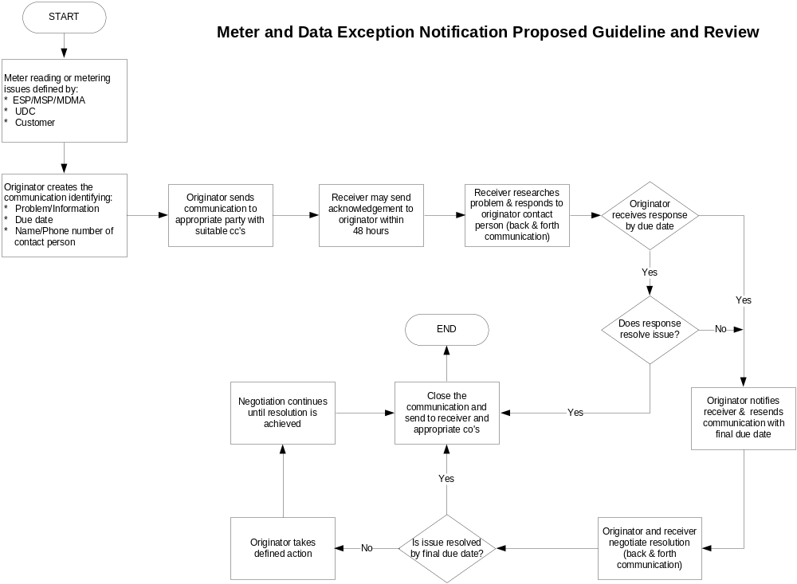

SCE MADEN Timeline
The following timeline is an example of how MADENs are processed when SCE does not receive data from a third-party MDMA. SCE’s timeline is based on calendar days.
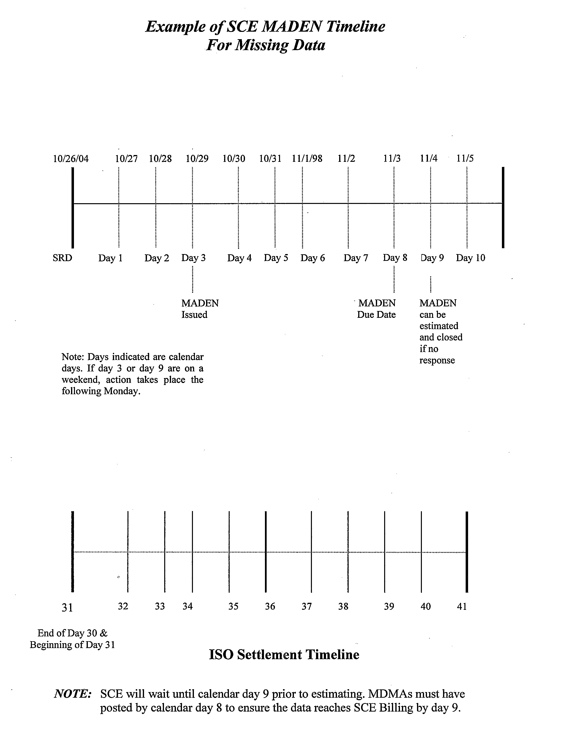

SDG&E MADEN Timeline
The following timeline is an example of how MADENs are processed when SDG&E does not receive data from a third-party MDMA. SDG&E’s timeline is based on business days.
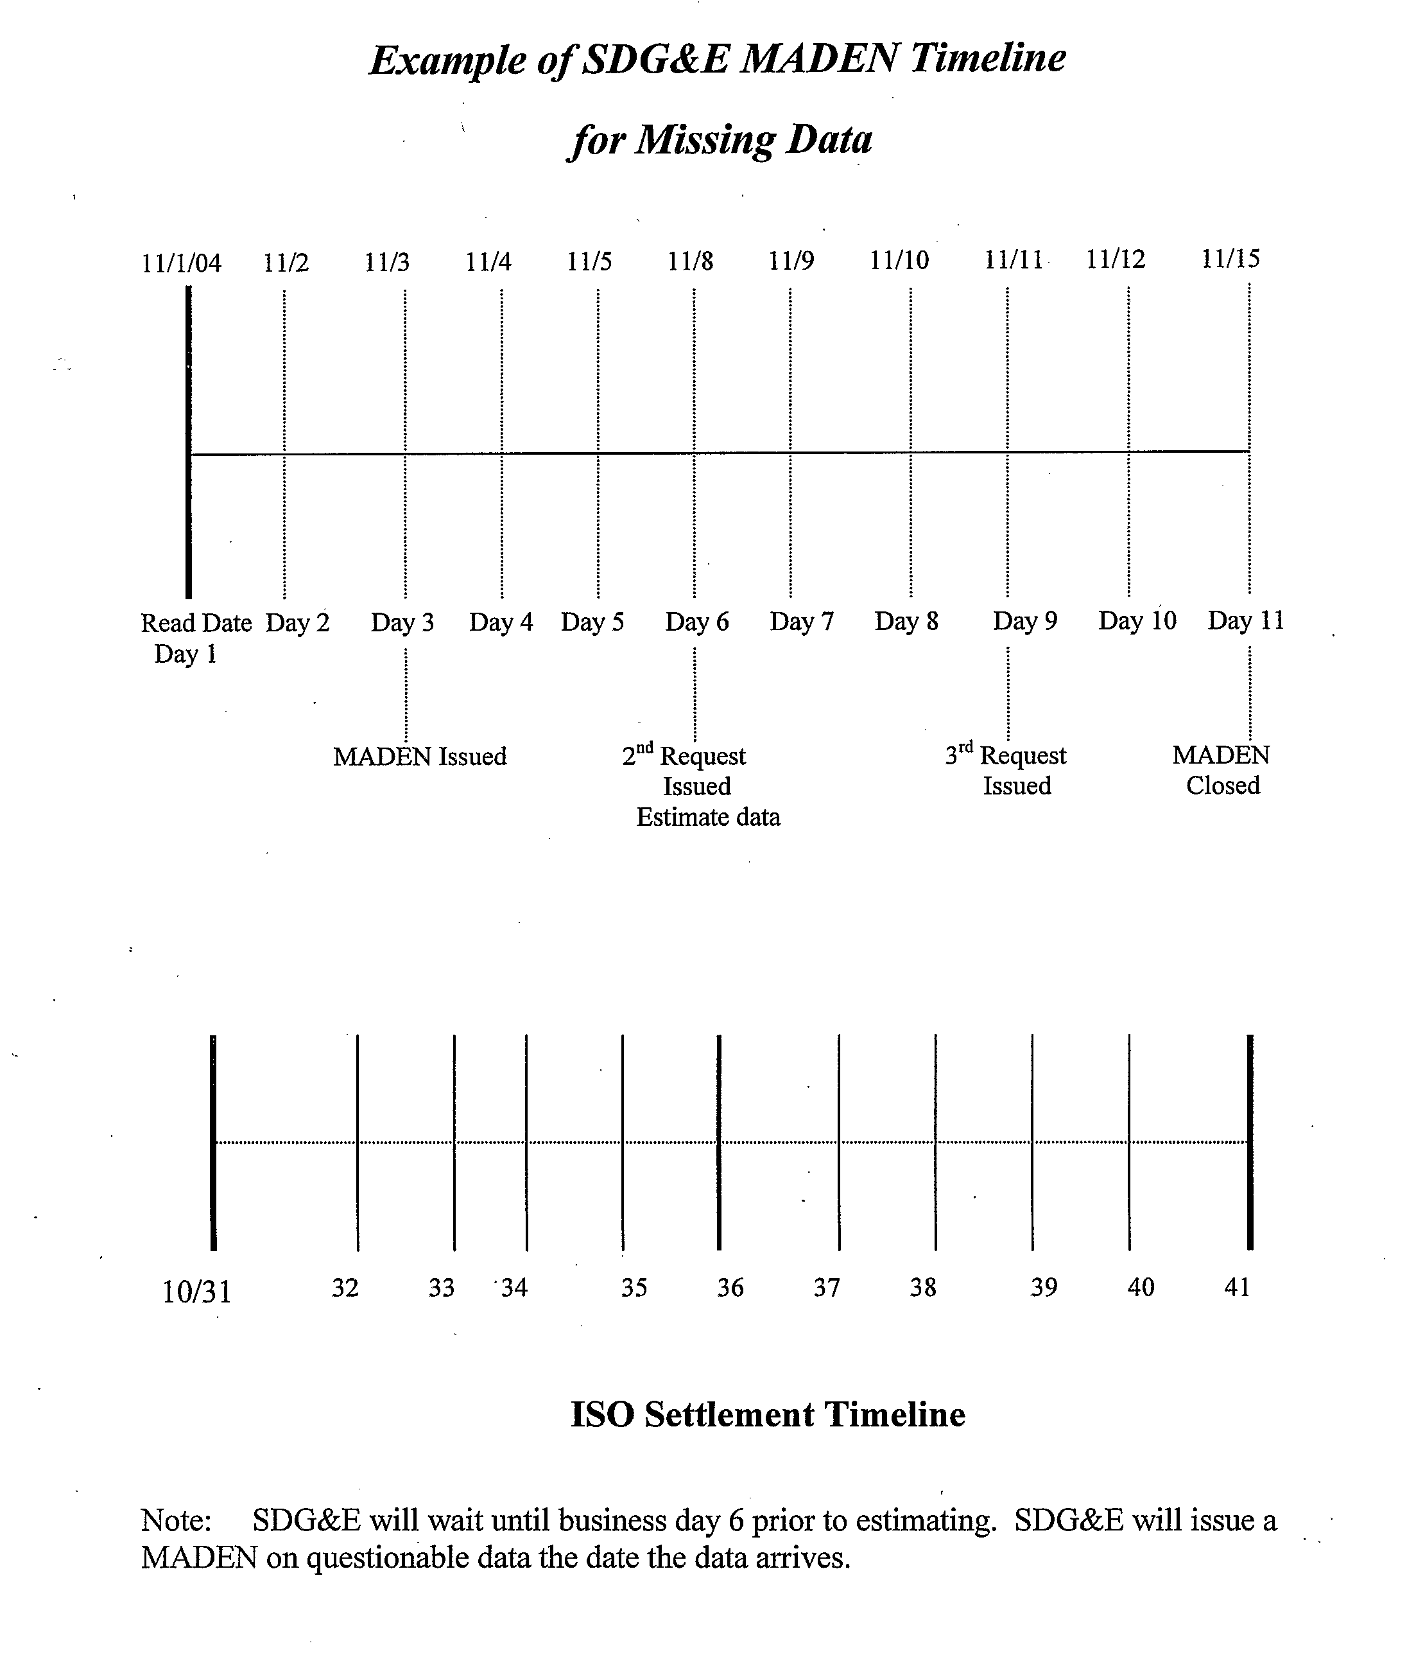

PG&E MADEN Timeline
The following timeline is an example of how MADENs are processed when PG&E does not receive data from a third-party MDMA. PG&E’s timeline is based on calendar days.
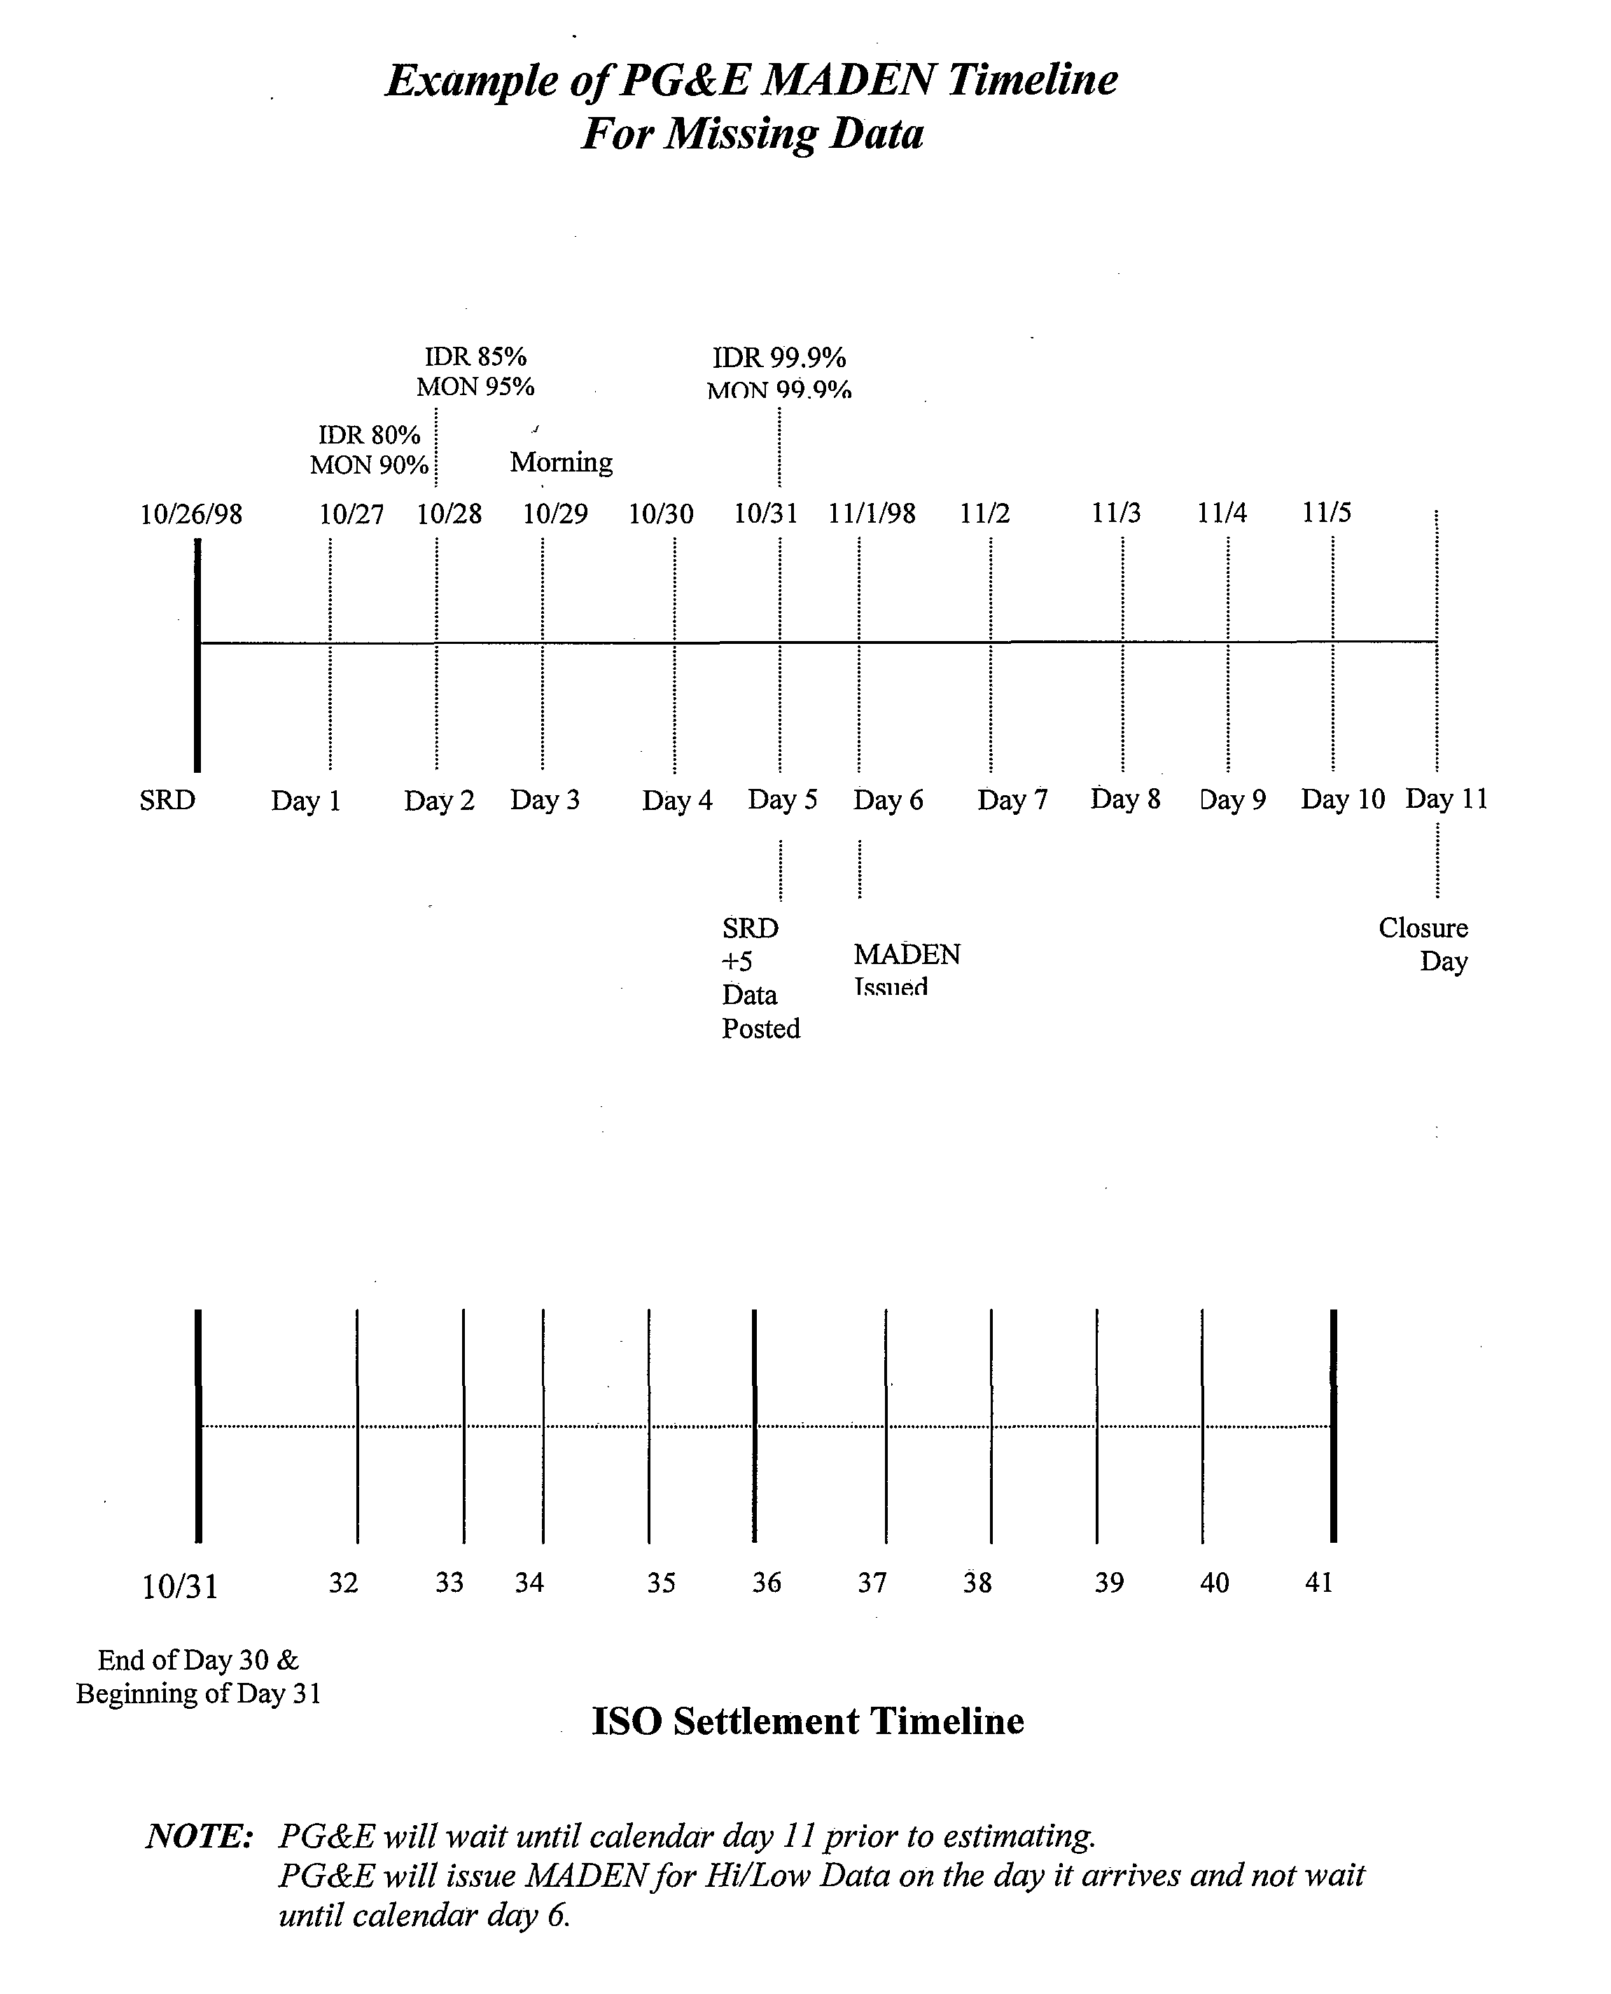

Sample SCE MADEN Data

MADEN #: xxxxx Date Sent: Thursday, October 21, 2004 Due Date: xx/xx/xx
MADEN Analyst: xxxx SDP: xx-xxxxxx-x-xxxxxxxxx
Email Address: metering@sce.com Phone#:1-800-203-4634 Fax#:1-626-967-8109
Service Account #: xxxxxx Meter ID: xx+xxx-xxxxxx
Customer Name: xxxxxxxxxxxxxx
Customer Address:
Street: xxxxx xxxxxx xx
City: xxxxx
State: xx
Request:
Comments:
Please return this form to:
Southern California Edison Meter Operations Administration 1-800-203-4634
Confidential

Sample SDG&E MADEN Data

Please correct the following problem with your direct access account:

MDEN INFORMATION

ESP ID: 111110110
MDEN#: 9999
Status: Missing Data
Date Sent: 2004-09-14
Due Date: 2004-09-18
Date Closed:
MDMA ID: 001101101
MSP ID:
Contact Name: Angela LaCerva
Phone: 858-654-1000
E-mail: Alacerva@semprautilities.com

CUSTOMER INFORMATION

Customer Name: JOHN #57
Address: 564 FAY AVE
City: LA JOLLA
Meter ID: 09011725
UDC Account Number: 9028770930
Date&Time of Event: 200409141514
ESP Account Number: 11114
Old UDC Acct Number: 5843178591
Service Delivery Point:
Billing Cycle: 08
Action Required: need data for dates below. Current file sent has incorrect start and
end times/dates We need data for the period 08/11/2004 00:15 to 09/12/2004 24:00(PST).

Comments:

MDEN RESPONSE

Respondents ID:
Name:
E-mail:
Phone:
Date Responding:

Response:

Sample PG&E MADEN Data – Third-Party MDMA

Sample OPEN MADEN – PG&E to ESP
UDC | MADEN | MDMA | ESP | Date Sent | Due Date | Contact Name | Email Address | Phone | Meter ID | Bill Cycle Start | Bill Cycle Stop | UDC Account No. | Old UDC No.
PGE | PGE10001 |  |  | 3/25/2004 | 3/30/2004 |  | IntervalinMADEN@PGE.COM | 415.xxx.xxxx | C9XXXX | 2/17/2004 | 3/18/2004 | 1000005005 | 8000001
PGE | PGE10002 |  |  | 3/25/2004 | 3/30/2004 |  | IntervalinMADEN@PGE.COM | 415.xxx.xxxx | CXXXX4 | 2/17/2004 | 3/18/2004 | 2000005005 | 8000002
PGE | PGE10003 |  |  | 3/25/2004 | 3/30/2004 |  | IntervalinMADEN@PGE.COM | 415.xxx.xxxx | CXXXX5 | 2/17/2004 | 3/18/2004 | 3000000506 | 8000003
PGE | PGE10004 |  |  | 3/25/2004 | 3/30/2004 |  | IntervalinMADEN@PGE.COM | 415.xxx.xxxx | CXXXX2 | 2/17/2004 | 3/18/2004 | 4000005XX7 | 8000004

MADEN Category | Comment | Suggested Resolution | Status | Customer Name | Customer Address | City | State | Zip | MADEN Response
MISSING DATA | WAITING FOR DATA; LAST READ 02/17/2004 24:00 | PLEASE POST DATA | OPEN | COMPANY A | 111 XXXX ST | BAKERSFIELD | CA | 94001
FAIL HIGH/LOW CHECK | DEMAND IS HIGH COMPARED TO HISTORY; HISTORICAL MAXIMUM DEMAND IS 517KW. MAX DEMAND SENT IS 1886KW | PLEASE VERIFY USAGE | OPEN | COMPANY B | 333 XXXX RD | SELMA | CA | 94002
MISSING DATA | NEVER RECEIVED KWH DATA | SWITCH DATE IS 1/18/04. PGE HAS NOT RECEIVED ANY DATA SINCE SWITCH DATE | OPEN | COMPANY C | 999 XXX AVE | SAN FRANCISCO | CA | 94003
MISSING DATA | MISSING 77% OF KWH AND 100% OF RKVAH DATA | PLEASE VERIFY BILLING SERIAL. PG&E SYSTEMS SHOW B SERIAL. IMSERV DATA FRAMED FOR C SERIAL. | OPEN | COMPANY D | 9 XXX WAY | BELMONT | CA | 94004

Sample MDMA RESPONSE - ESP to PG&E
UDC | MADEN | MDMA | ESP | Date Sent | Due Date | Contact Name | Email Address | Phone | Meter ID | Bill Cycle Start | Bill Cycle Stop | UDC Account No. | Old UDC No.
PGE | PGE10001 |  |  | 3/25/2004 | 3/30/2004 |  | IntervalinMADEN@PGE.COM | 415.xxx.xxxx | C9XXXX | 2/17/2004 | 3/18/2004 | 1000005005 | 8000001
PGE | PGE10002 |  |  | 3/25/2004 | 3/30/2004 |  | IntervalinMADEN@PGE.COM | 415.xxx.xxxx | CXXXX4 | 2/17/2004 | 3/18/2004 | 2000005005 | 8000002
PGE | PGE10003 |  |  | 3/25/2004 | 3/30/2004 |  | IntervalinMADEN@PGE.COM | 415.xxx.xxxx | CXXXX5 | 2/17/2004 | 3/18/2004 | 3000000506 | 8000003
PGE | PGE10004 |  |  | 3/25/2004 | 3/30/2004 |  | IntervalinMADEN@PGE.COM | 415.xxx.xxxx | CXXXX2 | 2/17/2004 | 3/18/2004 | 4000005XX7 | 8000004

MADEN Category | Comment | Suggested Resolution | Status | Customer Name | Customer Address | City | State | Zip | MADEN Response
MISSING DATA | WAITING FOR DATA; LAST READ 02/17/2004 24:00 | PLEASE POST DATA | OPEN | COMPANY A | 111 XXXX ST | BAKERSFIELD | CA | 94001 | Data is posted to: 01/28/04 00:01, 02/27/04 00:00, PGE20040308101904011211.edi
FAIL HIGH/LOW CHECK | DEMAND IS HIGH COMPARED TO HISTORY; HISTORICAL MAXIMUM DEMAND IS 517KW. MAX DEMAND SENT IS 1886KW. | PLEASE VERIFY USAGE | OPEN | COMPANY B | 333 XXXX RD | SELMA | CA | 94002 | We do not see the high demand of 1886kw; our maximum demand for this billing period is 517kw.
MISSING DATA | NEVER RECEIVED KWH DATA | SWITCH DATE IS 1/18/04. PGE HAS NOT RECEIVED ANY DATA SINCE SWITCH DATE. | OPEN | COMPANY C | 999 XXX AVE | SAN FRANCISCO | CA | 94003 | Account has not been set up in our system. Will verify account status with ESP.
MISSING DATA | MISSING 77% OF KWH AND 100% OF RKVAH DATA | PLEASE VERIFY BILLING SERIAL. PG&E SYSTEMS SHOW B SERIAL. IMSERV DATA FRAMED FOR C SERIAL. | OPEN | COMPANY D | 9 XXXX WAY | BELMONT | CA | 94004 | Updated serial information and reposted data under correct serial.

Sample CLOSED MADEN – PG&E to ESP
UDC | MADEN | MDMA | ESP | Date Sent | Due Date | Contact Name | Email Address | Phone | Meter ID | Bill Cycle Start | Bill Cycle Stop | UDC Account No. | Old UDC No.
PGE | PGE10001 |  |  | 3/25/2004 | 3/30/2004 |  | IntervalinMADEN@PGE.COM | 415.xxx.xxxx | C9XXXX | 2/17/2004 | 3/18/2004 | 1000005005 | 8000001
PGE | PGE10002 |  |  | 3/25/2004 | 3/30/2004 |  | IntervalinMADEN@PGE.COM | 415.xxx.xxxx | CXXXX4 | 2/17/2004 | 3/18/2004 | 2000005005 | 8000002
PGE | PGE10003 |  |  | 3/25/2004 | 3/30/2004 |  | IntervalinMADEN@PGE.COM | 415.xxx.xxxx | CXXXX5 | 2/17/2004 | 3/18/2004 | 3000000506 | 8000003
PGE | PGE10004 |  |  | 3/25/2004 | 3/30/2004 |  | IntervalinMADEN@PGE.COM | 415.xxx.xxxx | CXXXX2 | 2/17/2004 | 3/18/2004 | 4000005XX7 | 8000004

MADEN Category | Comment | Suggested Resolution | Status | Customer Name | Customer Address | City | State | Zip | MADEN Response
BILLED | BILLED USING MDMA DATA |  | CLOSED | COMPANY A | 111 XXXX ST | BAKERSFIELD | CA | 94001
BILLED | BILLED USING MDMA DATA |  | CLOSED | COMPANY B | 333 XXXX RD | SELMA | CA | 94002
BILLED | BILLED USING 100% ESTIMATED DATA |  | CLOSED | COMPANY C | 999 XXX AVE | SAN FRANCISCO | CA | 94003
BILLED | BILLED USING MDMA DATA |  | CLOSED | COMPANY D | 9 XXXX WAY | BELMONT | CA | 94004

PG&E ESP Action Report
PG&E uses the ESP Action Report to notify ESPs of non-data related issues the ESP is responsible for, including meter installations, maintenance, DA panel upgrades, phone line, and DASR-related issues. PG&E only uses the ESP Action Report when PG&E is either the Meter Service Provider (MSP) and/or the Meter Data Management Agent (MDMA).

PG&E Metering Issues
For metering issues, including DA meter installations and DA panel upgrades, PG&E sends an ESP Action Report notifying the ESP of the issue and if phone line work is needed. After required phone work is completed, the ESP fills out and returns the Phone Service Notification form to PG&E by fax at (415) 973-2490 or email to DCS CRT Mitss-Meg.
The following table lists problem symptoms, possible causes, and actions to resolve metering issues.
Metering Issues
Problem Symptom | Possible Cause(s) | Actions Required | Time to Resolve
DA installation/panel upgrade | No phone line tagged/ installed near meter. | ESP verifies with phone company that phone is tagged and installed properly. | 30-60 days
I/O Time-out | Meter not staying on long enough to download data. | MSP troubleshoots meter. May need to replace meter. | 30 days or the *next serial read date
Encoders & Pulse Not in sync | Connecting OK, but meter needs to be reprogrammed to get encoders and pulse in sync. | Reprogram meter. | 30 days or the *next serial read date
Access problem/ Unable to collect HHF | Meter technician cannot access premise to collect HHF. | Obtain site contact for access. | 30 days or the *next serial read date
Security error - Password issue | Passwords not working in the meter and PG&E. | PGE, as MSP, retrieves correct passwords from Master File or third party or reprograms / replaces meter. | 30 days or the *next serial read date
Id mismatch | - Incorrect ID # entered in MV-90  - Incorrect ID # programmed in the Field  - Problem with Line Sharing switch | Reprogram or replace meter. | 30 days or the *next serial read date
Battery failure | When a failure is detected in the recorder battery and charging circuit. | Replace battery or replace meter. | 30 days or the *next serial read date
Hardware clock error | MV-90 generated error when doing remote interrogation. | Reprogram meter. | 30 days or the *next serial read date
DST set wrong | There is a one-hour difference between the actual time and meter time. | Reprogram meter. | 30 days or the *next serial read date
RAM failure | - Computer crashed  - Power outage and back-up battery is dead  - A RAM failure occurred | Replace meter. | 30 days or the *next serial read date
Gap in data | Power outage or meter was tested and result showed gap in data. | Collect HHF – may also reprogram or replace meter. | 30 days or the *next serial read date
Low usage | Site is vacant or site is being remodeled so there is minimal usage. | Troubleshoot – may also reprogram or replace meter. | 30 days or the *next serial read date
Lost program | The working memory of the meter crashed (RAM) or there was a power outage and the battery is dead. | Reprogram or replace meter. | 30 days or the *next serial read date
Meter change | Meter crash or bad meter. | Replace meter. | 30 days or the *next serial read date
No encoder | Pulses are not converted to kilowatt. Wrong encoder value. | Reprogram or replace meter. | 30 days or the *next serial read date
No new pulse data or not validating pulse data | The meter has not been initialized or the meter has crashed. The power loop supply that sends energy pulses from the meter to the recorder fails. The recorder has not accumulated enough data to read. | Reprogram or replace meter. | 30 days or the *next serial read date
Meter shipment | Meter change | Instructions to ESP on where meter should be sent when PG&E is the MSP. | 30 days or the *next serial read date
Duplicate badge | Two meter numbers are displayed at different sites. | Rebadge meter. | 30 days or the *next serial read date
DASR issues on ancillary relationship roles | Wrong DASR roles submitted by the ESP. | Resubmit accurate DASR. | 30 days or the *next serial read date
Panel upgrades | - Relocation  - CT/PT changes  - Increase in load | Joint meet if PG&E not MSP – meters may be changed, load transferred, etc. | 30-60 days or the *next serial read date
Connectivity Issues
Ring-No-Answer | Bad Line Sharing Switch (LSS). Lines no longer connected to meter. | MSP sends a technician to correct. May need to replace/reprogram LSS or verify connection between phone and meter. | 30-60 days or the *next serial read date
Dead phone line/no dial tone at meter | Faulty meter, modem, or phone connection. | ESP replaces meter/modem or sends phone technician to troubleshoot phone connection. | 30-60 days or the *next serial read date
Dead phone line/no dial tone at Main Point of Entry (MPOE) | Faulty phone connection. | ESP sends phone technician to troubleshoot phone connection. | 30-60 days or the *next serial read date
Dead phone line between MPOE and meter | Faulty phone connection. | ESP sends phone technician to troubleshoot phone connection. | 30-60 days or the *next serial read date
Disconnected phone line | Disconnected phone connection due to non-pay, relocation of meter panel, or shut-down location. | ESP verifies and reactivates phone line for MDMA/PG&E. | 30-60 days or the *next serial read date
Error Message when calling Cell Phone | Faulty cell phone/no coverage or incorrect active phone features. | ESP provides MSP with new cell phone and active number. | 30-60 days or the *next serial read date
Phone line needs to be transferred | Phone lines currently paid by PG&E should be paid by ESP. | ESP takes ownership of phone lines and PG&E relinquishes ownership. | 30-60 days or the *next serial read date
*The next serial read date is the preferred time of resolution. If a problem is not resolved within required timeframes, PG&E will take steps to resolve the issue.
The following are two typical scenarios where PG&E sends an ESP Action Report to resolve maintenance problems involving connectivity issues.
Scenario 1: PG&E is the MSP and/or the MDMA
When PG&E is the MSP and/or the MDMA, PG&E receives an email from the ESP at DCS CRT Mitss-Meg or a notification from the PG&E TMSC that there is a connectivity issue. PG&E then troubleshoots in an attempt to resolve the problem.
If PG&E is unable to resolve the problem, PG&E sends an ESP Action Report so the ESP can follow up and resolve the issue. Once the problem is resolved, the ESP or the third-party MSP notifies the PG&E TMSC at 1-800-373-7013, Option 1.
Scenario 2: PG&E is the MDMA, but not the MSP
When PG&E is the MDMA but not the MSP, PG&E sends an ESP Action Report so the ESP can follow up and resolve the issue. Once the problem is resolved, the ESP or the 3rd Party MSP notifies the PG&E TMSC at 1-800-373-7013, Option 1.
Notes:
- When PG&E is neither the MSP nor the MDMA, PG&E uses a MADEN to notify parties of connectivity issues and resolve problems. (See page 37 for detailed instructions regarding the MADEN process.)
- More often that not, the reason PG&E sends an ESP Action Report is due to a phone line problem that the ESP needs to resolve with the phone service provider.

Sample ESP Action Report



